**Spin up a fresh Ubuntu VM via Vagrant**

1.1 Let’s Setup Vagrant:

For complete setup Vagrant in Host Machine we need some Prerequisites:

**Virtual Box & Ubuntu 16.04 Vagrant Box**

1. Download the VirtualBox Tool – To download this tool visit the website <https://www.virtualbox.org/>

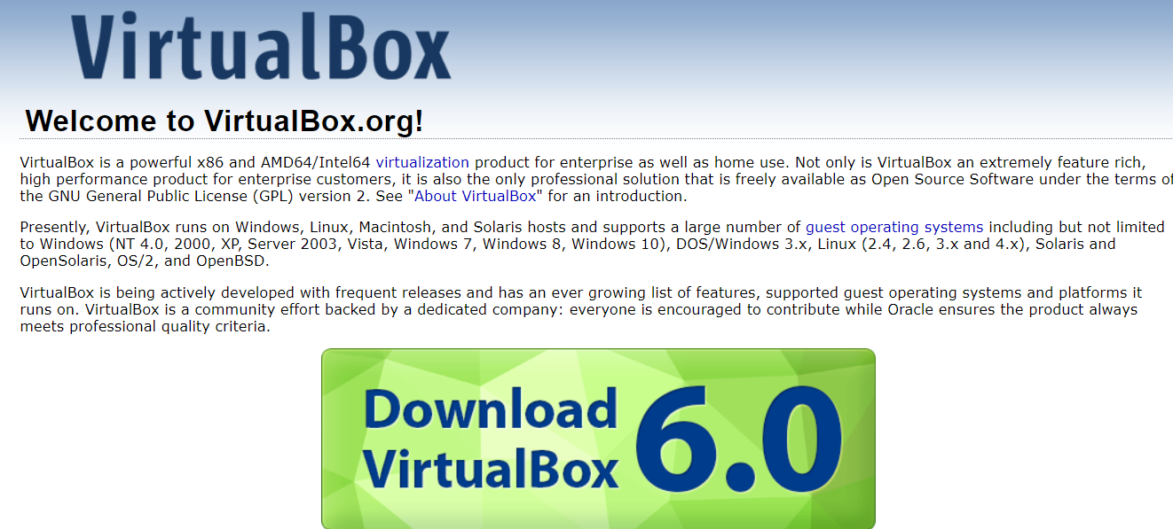

After downloading the **Virtual Box** install it on your system (Windows, Mac etc).

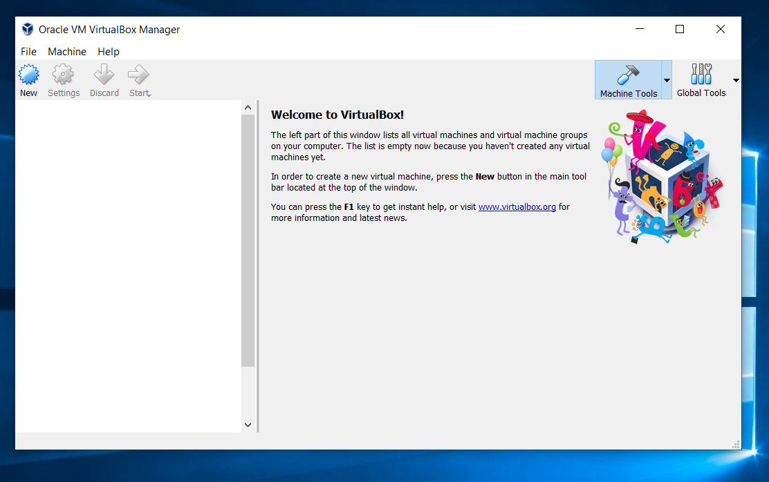

**2. Now we are going to setup Fresh Ubuntu Platform using in Virtual Box tools via Vagrant.**

* 1. Download Vagrant and Install it on your system- <https://www.vagrantup.com/>

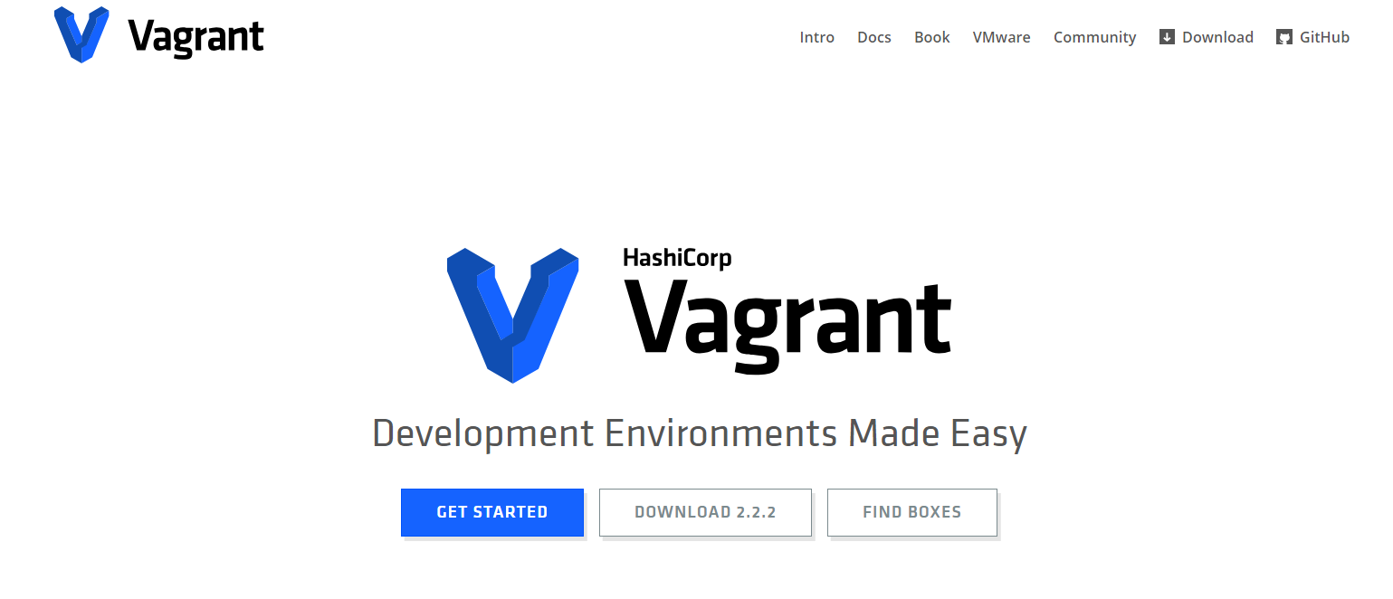

To go to this step we are going to use a terminal for shell scripting. I am using Gitbash. You can use as per Operating system Terminal (Like Windows Terminal, Term (Mac) etc.)

As per your operating system you can download.

Gitbash- - <https://git-scm.com/downloads> For Windows

Iterm2 - <https://www.iterm2.com/> For Mac

I am using Gitbash

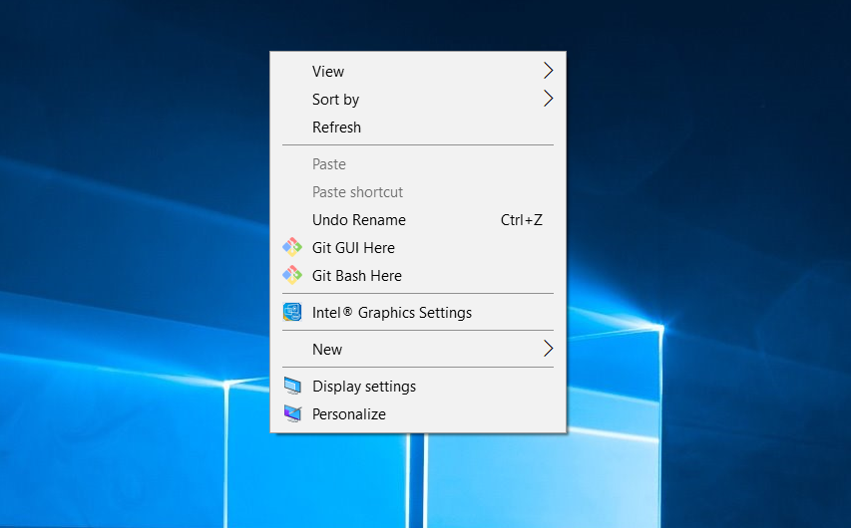

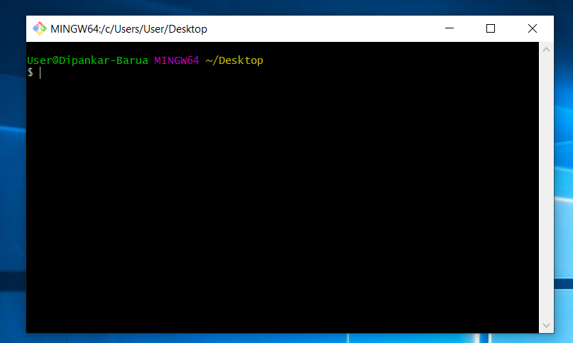

If you want to check that Vagrant has been installed then run the command **vagrant –v**

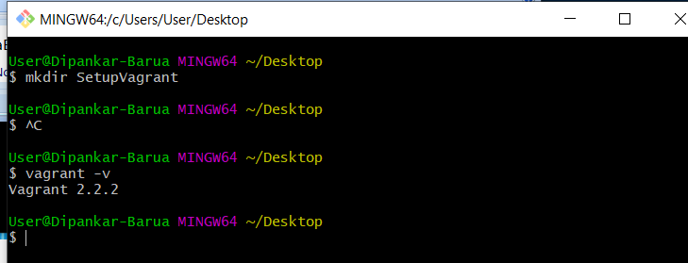

$ vagrant -v

Vagrant 2.2.2

**Let’s create a folder on Desktop using Terminal**

Run below command on Terminal

User@Dipankar-Barua MINGW64 ~/Desktop

$ mkdir SetupVagrant

User@Dipankar-Barua MINGW64 ~/Desktop

$

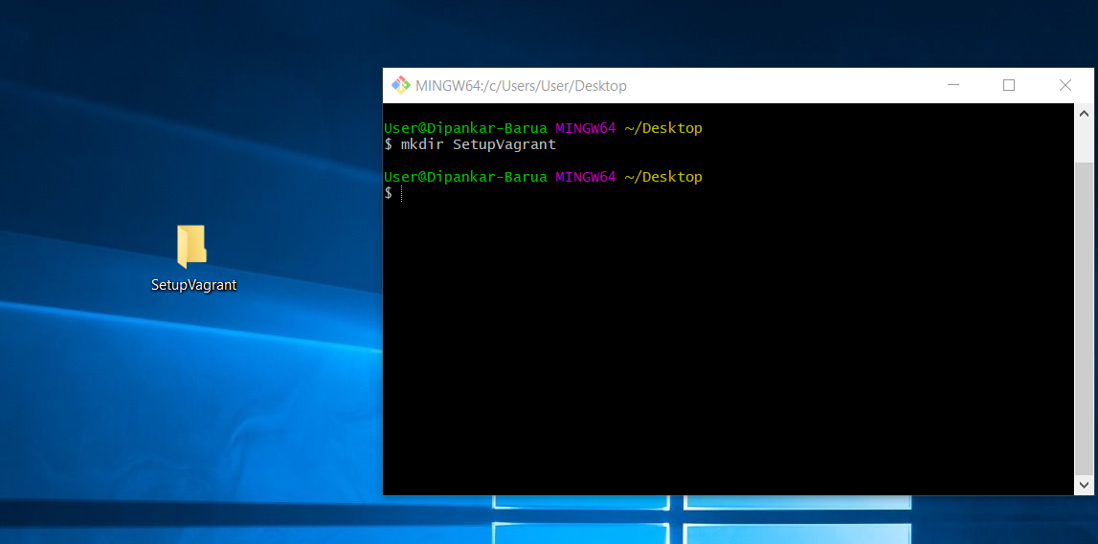

Now we have setup installations VM & Vagrant in system. Figure is below

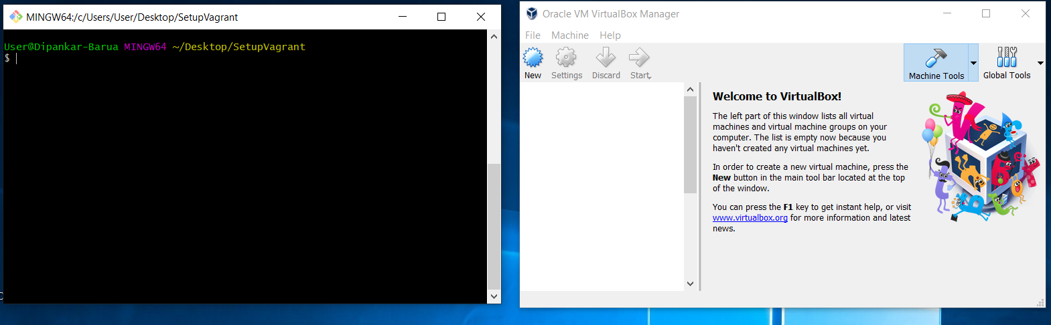

I am going to open the Folder SetupVagrant using Visual Studio code.

Run command on terminal

Code .

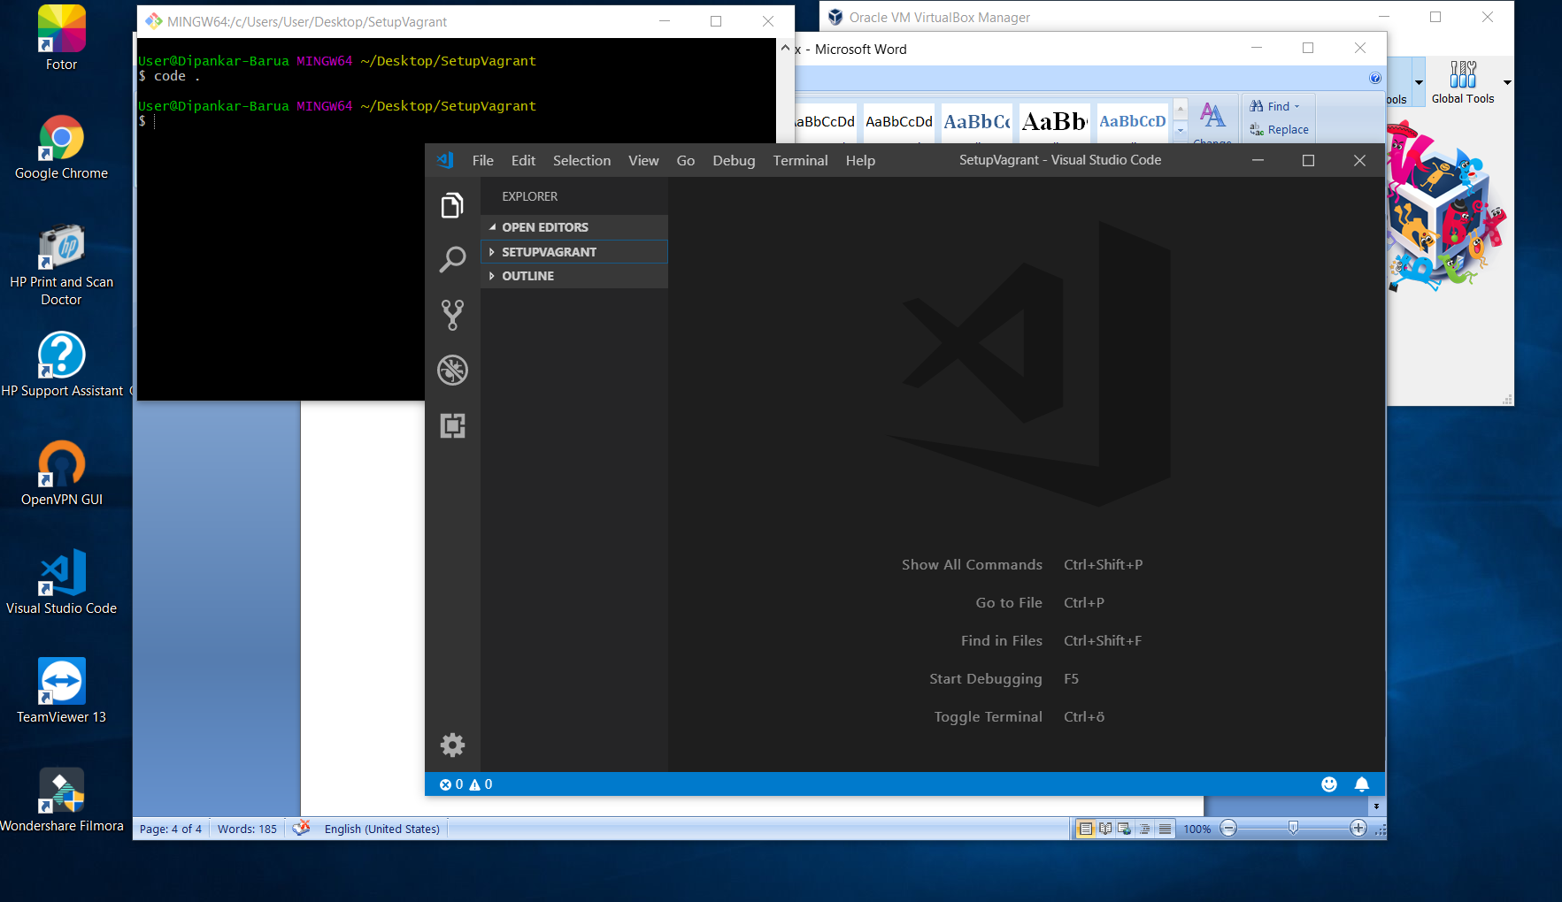

**Below Process are the configurations of Vagrant Setup**

**config.vm.box** - operating system

**config.vm.provider** - Virtualbox

**config.vm.network** - How your host sees your box

**config.vm.synced** - how you access files from your computer

**config.vm.provision** - what want to setup

**Let’s setup Vagrant Ubuntu Boxes on VM**

To find out the vagrant box visit <https://app.vagrantup.com/boxes/search>

We are going to select the Ubuntu 16.04 Vagrant Box for the **Virtual Box**

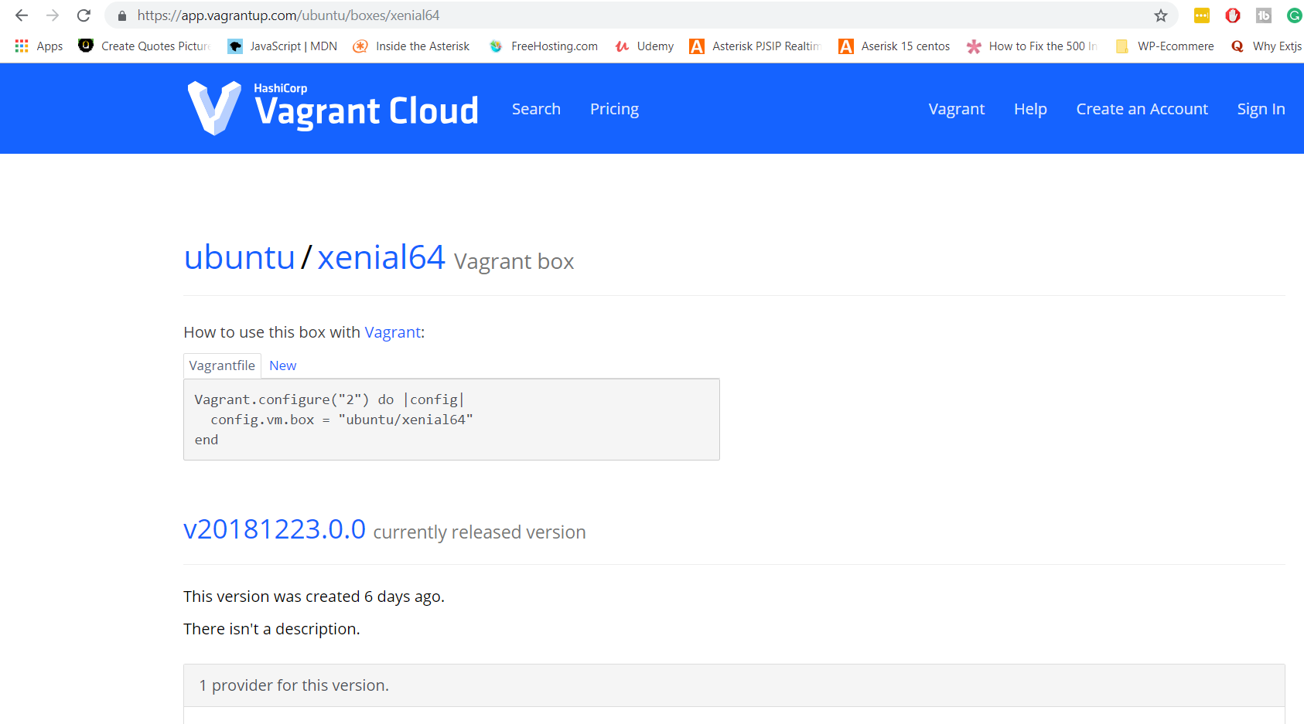

vagrant init ubuntu/xenial64

vagrant up

Notes: Initially I used First 14.0 Ubuntu Vagrant Box Then later I thought recommended is 16.04. The Later I used 16.04 Ubuntu Vagrant Box

After creating Vagrant File

I have changes

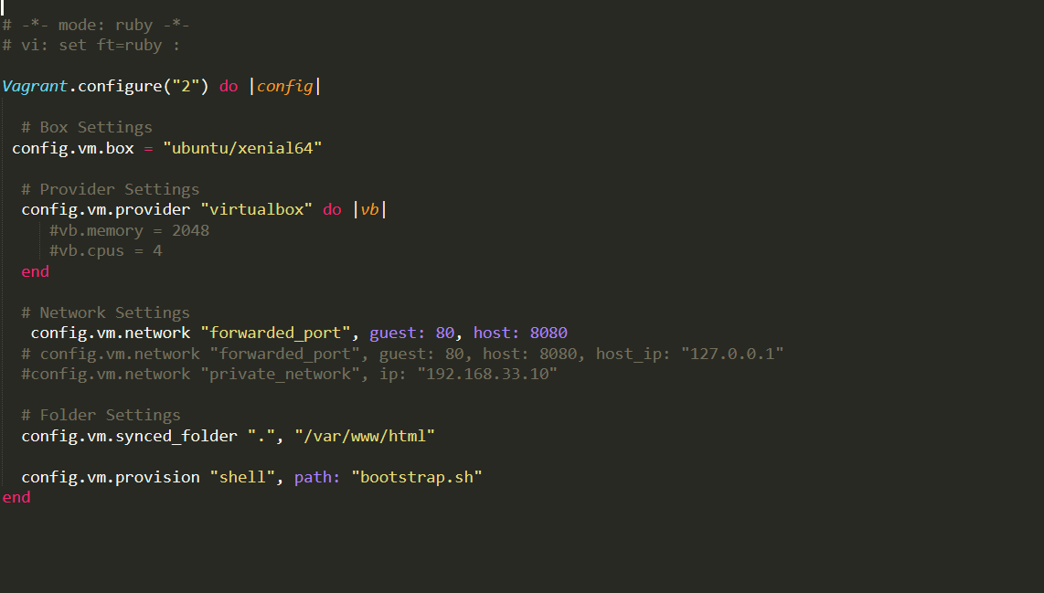

#Provider setting

config.vm.provider "virtualbox" do |vb|

end

# Display the VirtualBox GUI when booting the machine

# vb.gui = true

#

# # Customize the amount of memory on the VM:

# vb.memory = "1024"

#newtwork setting

# config.vm.network "forwarded_port", guest: 80, host: 8080

# config.vm.network "forwarded_port", guest: 80, host: 8080, host_ip: "127.0.0.1"

# config.vm.network "private_network", ip: "192.168.33.10"

# config.vm.network "public_network"

#Folder setting

# config.vm.synced_folder "../data", "/vagrant_data"

#Provision setting

# config.vm.provision "shell", inline: <<-SHELL

# apt-get update

# apt-get install -y apache2

# SHELL

end

Then Next I run the Command vagrant up

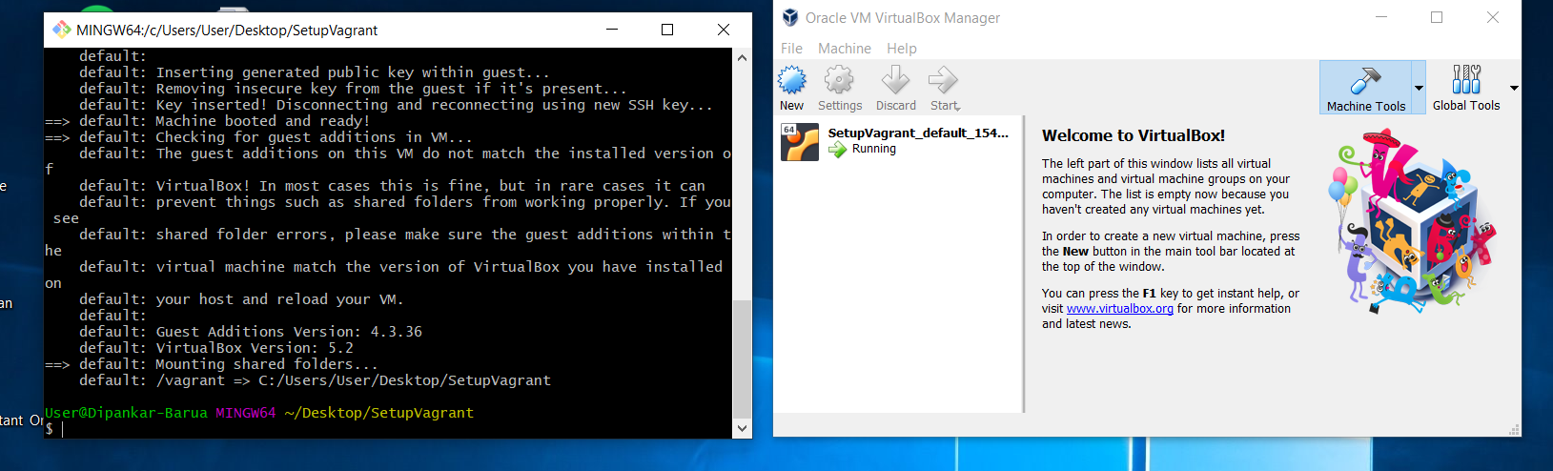

The logs after run the command vagrant up

Bringing machine 'default' up with 'virtualbox' provider...

==> default: Importing base box 'ubuntu/trusty64'...

==> default: Matching MAC address for NAT networking...

==> default: Checking if box 'ubuntu/trusty64' is up to date...

==> default: Setting the name of the VM: SetupVagrant_default_1545842663884_87801

==> default: Clearing any previously set forwarded ports...

==> default: Vagrant has detected a configuration issue which exposes a

==> default: vulnerability with the installed version of VirtualBox. The

==> default: current guest is configured to use an E1000 NIC type for a

==> default: network adapter which is vulnerable in this version of VirtualBox.

==> default: Ensure the guest is trusted to use this configuration or update

==> default: the NIC type using one of the methods below:

==> default:

==> default: https://www.vagrantup.com/docs/virtualbox/configuration.html#default-nic-type

==> default: https://www.vagrantup.com/docs/virtualbox/networking.html#virtualbox-nic-type

==> default: Clearing any previously set network interfaces...

==> default: Preparing network interfaces based on configuration...

default: Adapter 1: nat

==> default: Forwarding ports...

default: 22 (guest) => 2222 (host) (adapter 1)

==> default: Booting VM...

==> default: Waiting for machine to boot. This may take a few minutes...

default: SSH address: 127.0.0.1:2222

default: SSH username: vagrant

default: SSH auth method: private key

default: Warning: Connection aborted. Retrying...

default: Warning: Connection reset. Retrying...

default: Warning: Connection aborted. Retrying...

default:

default: Vagrant insecure key detected. Vagrant will automatically replace

default: this with a newly generated keypair for better security.

default:

default: Inserting generated public key within guest...

default: Removing insecure key from the guest if it's present...

default: Key inserted! Disconnecting and reconnecting using new SSH key...

==> default: Machine booted and ready!

==> default: Checking for guest additions in VM...

default: The guest additions on this VM do not match the installed version of

default: VirtualBox! In most cases this is fine, but in rare cases it can

default: prevent things such as shared folders from working properly. If you see

default: shared folder errors, please make sure the guest additions within the

default: virtual machine match the version of VirtualBox you have installed on

default: your host and reload your VM.

default:

default: Guest Additions Version: 4.3.36

default: VirtualBox Version: 5.2

==> default: Mounting shared folders...

default: /vagrant => C:/Users/User/Desktop/SetupVagrant

**Some Important command For Vagrant**

**For Destroying- vagrant destroy**

**For suspend- vagrant suspend**

**For resuming – vagrant resume**

We can also change VM base memory and ram

vb.memory=2048

vb.cpus =4

in the vagrant file

after saving the file we can reload vagrant -- reload then it will change

Now we gonna install vagrant ssh using command vagrant ssh

**Logs below**

$ vagrant ssh

Welcome to Ubuntu 14.04.5 LTS (GNU/Linux 3.13.0-163-generic x86_64)

* Documentation: https://help.ubuntu.com/

System information as of Wed Dec 26 17:02:38 UTC 2018

System load: 0.69 Processes: 128

Usage of /: 3.6% of 39.34GB Users logged in: 0

Memory usage: 4% IP address for eth0: 10.0.2.15

Swap usage: 0%

Graph this data and manage this system at:

https://landscape.canonical.com/

Get cloud support with Ubuntu Advantage Cloud Guest:

http://www.ubuntu.com/business/services/cloud

0 packages can be updated.

0 updates are security updates.

New release '16.04.5 LTS' available.

Run 'do-release-upgrade' to upgrade to it.

vagrant@vagrant-ubuntu-trusty-64:~$

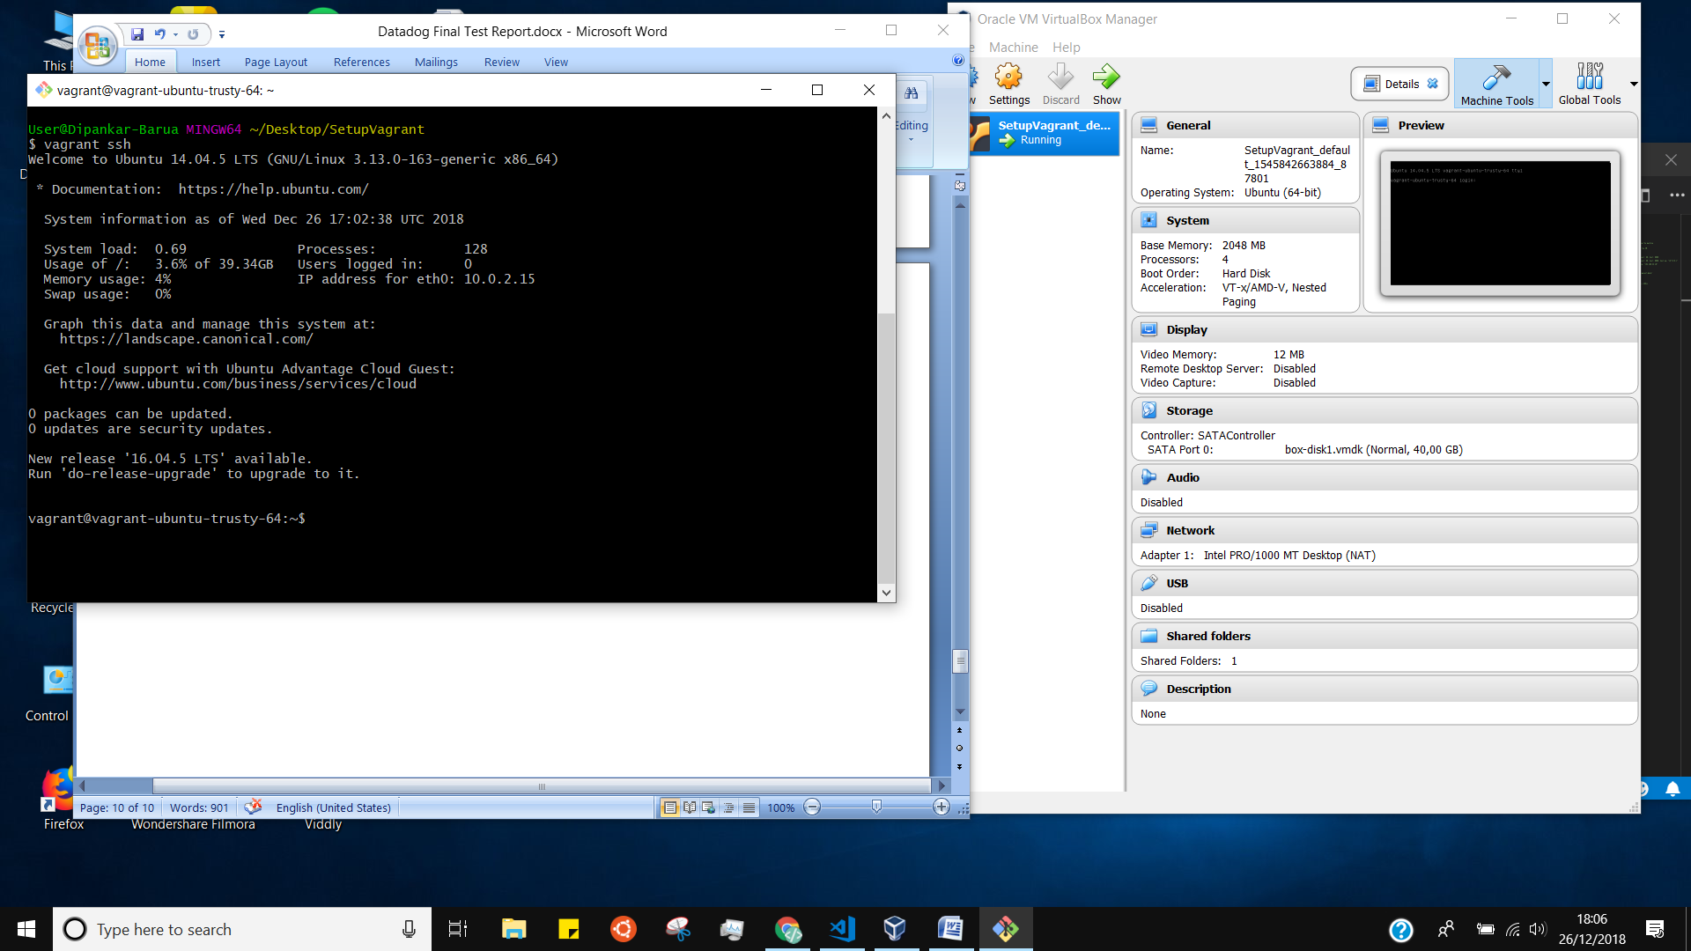

**If we search now var /www we will not find for that we have to install apache2**

**Lets Run the below command**

Sudo apt-get update

Sudo apt-get install –y git

Sudo apt-get install –y apache2

vagrant@vagrant-ubuntu-trusty-64:~$ ls /var/www

html

vagrant@vagrant-ubuntu-trusty-64:~$ ls /var/www/html

index.html

vagrant@vagrant-ubuntu-trusty-64:~$

**For networking localhost has setup in vagrant file and saved the file**

config.vm.network "forwarded_port", guest: 80, host: 8080

logs –

Setting up ssl-cert (1.0.33) ...

Processing triggers for libc-bin (2.19-0ubuntu6.14) ...

Processing triggers for ufw (0.34~rc-0ubuntu2) ...

Processing triggers for ureadahead (0.100.0-16) ...

vagrant@vagrant-ubuntu-trusty-64:~$ ls var/www/html

ls: cannot access var/www/html: No such file or directory

vagrant@vagrant-ubuntu-trusty-64:~$ clear

vagrant@vagrant-ubuntu-trusty-64:~$ ls /var/www

html

vagrant@vagrant-ubuntu-trusty-64:~$ cd html

-bash: cd: html: No such file or directory

vagrant@vagrant-ubuntu-trusty-64:~$ cd html

-bash: cd: html: No such file or directory

vagrant@vagrant-ubuntu-trusty-64:~$ ls /var/www/html

index.html

vagrant@vagrant-ubuntu-trusty-64:~$ exit

logout

Connection to 127.0.0.1 closed.

User@Dipankar-Barua MINGW64 ~/Desktop/SetupVagrant

$ vagrant reload

==> default: Attempting graceful shutdown of VM...

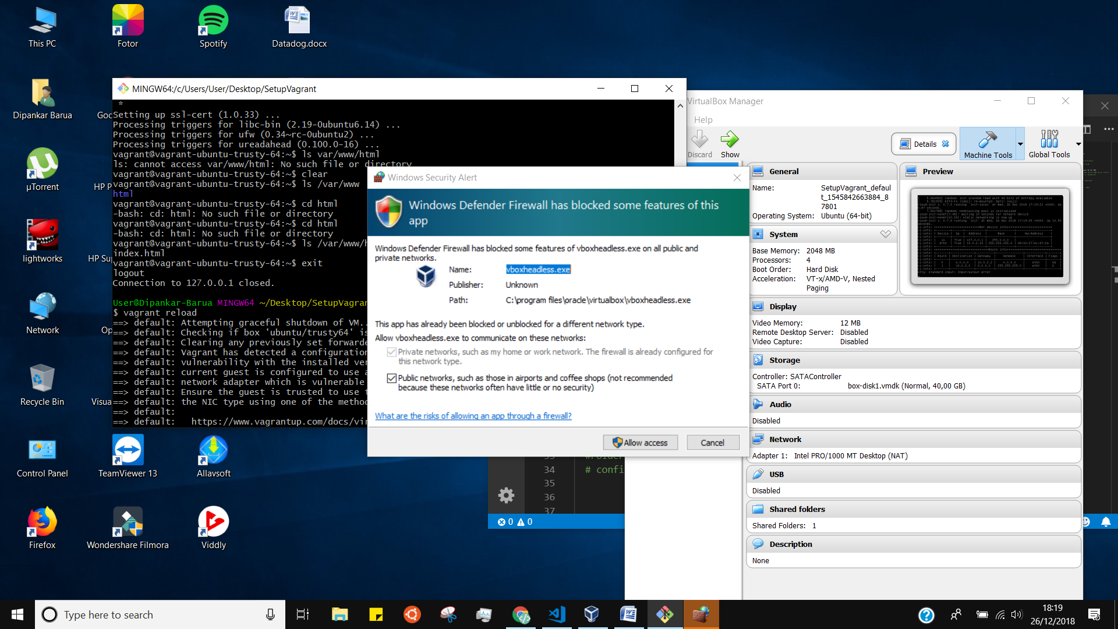

Apache setup

http://localhost:8080/

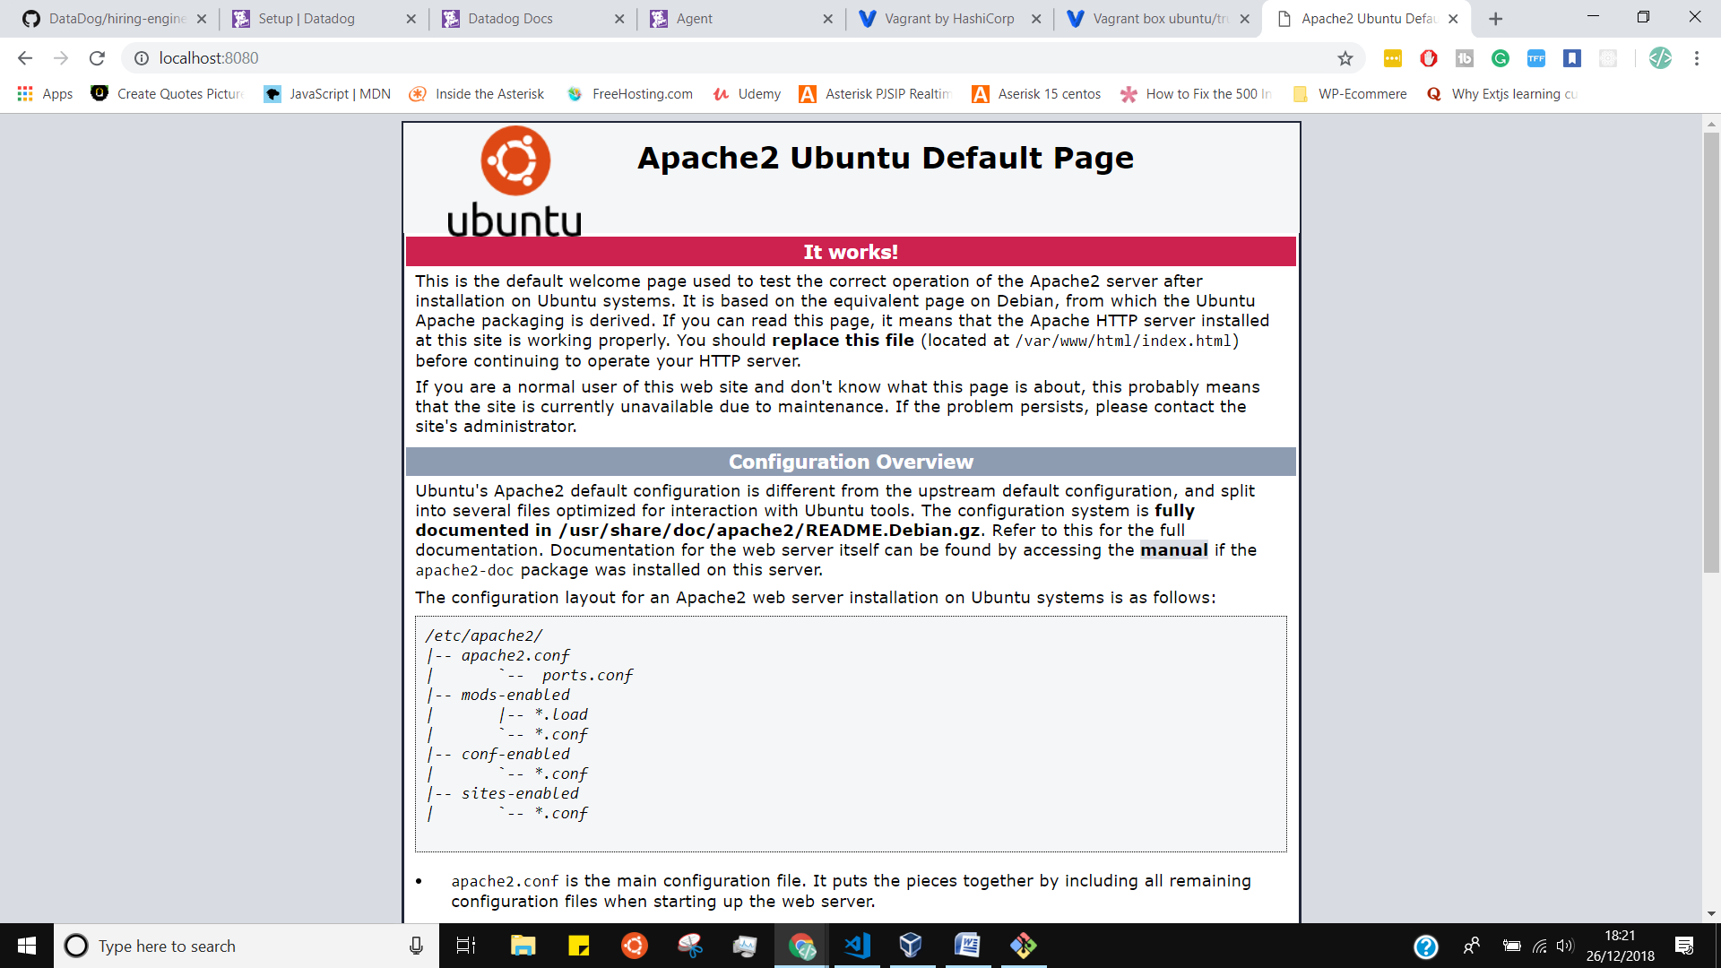

We can also use local private network using vagrant file network setting config.vm.network "private_network", ip: "192.168.33.10"

<http://192.168.33.10/>

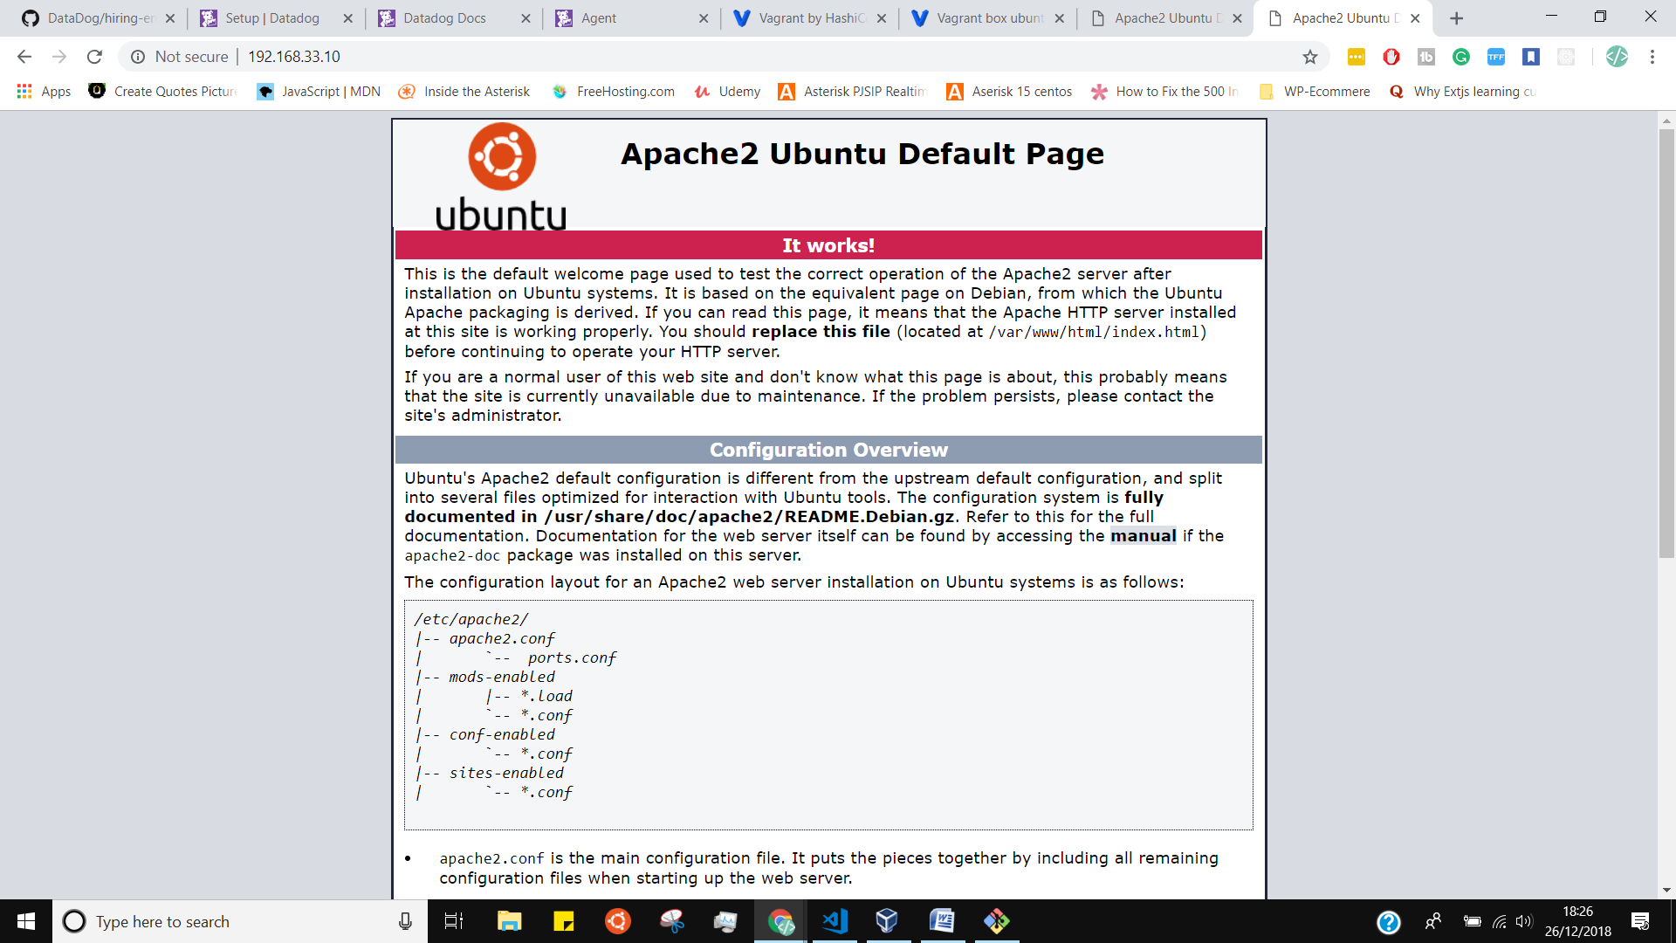

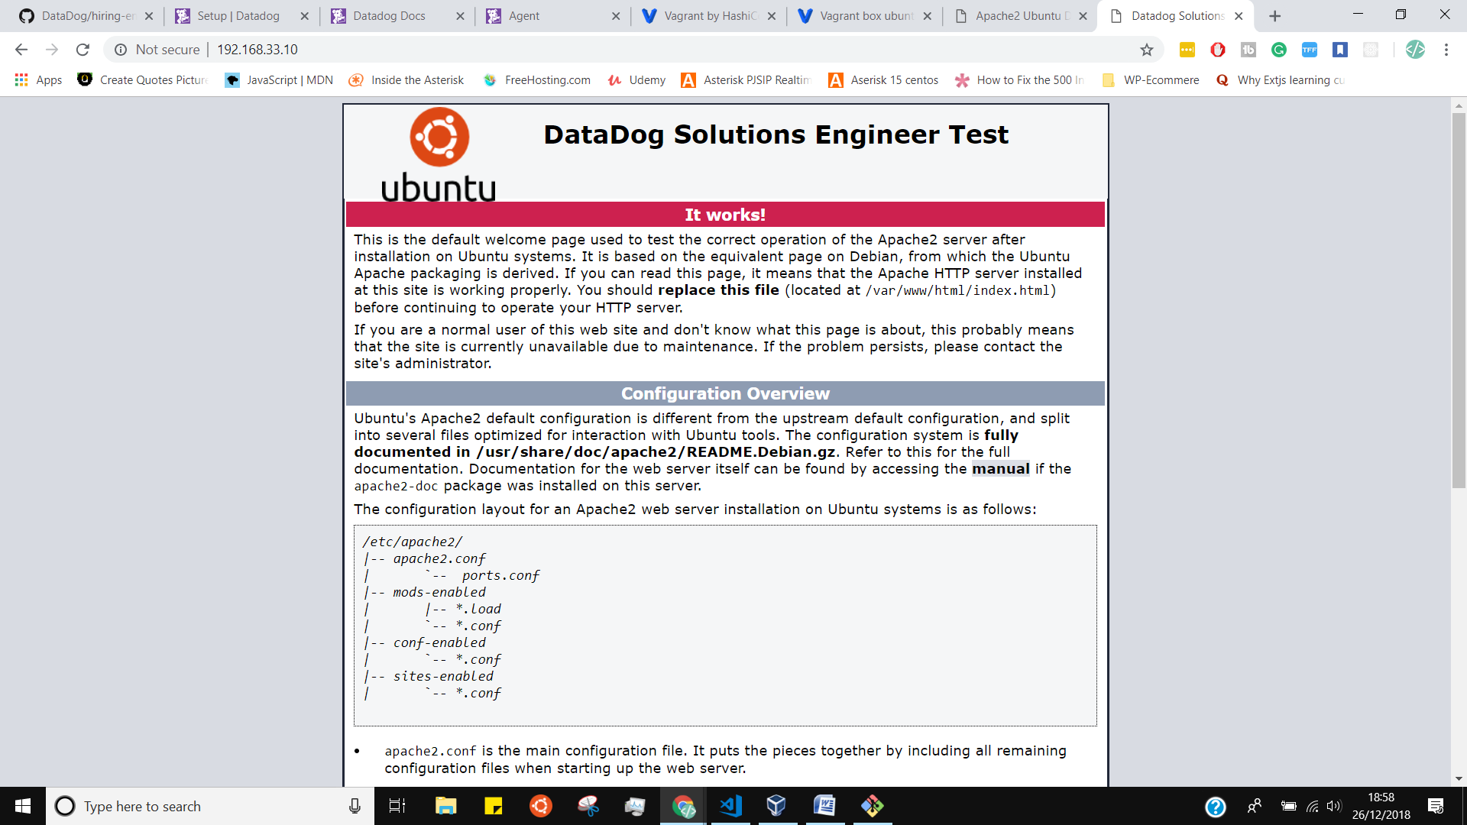

#Folder setting

config.vm.synced_folder ".", "/var/www/html"

config file sync

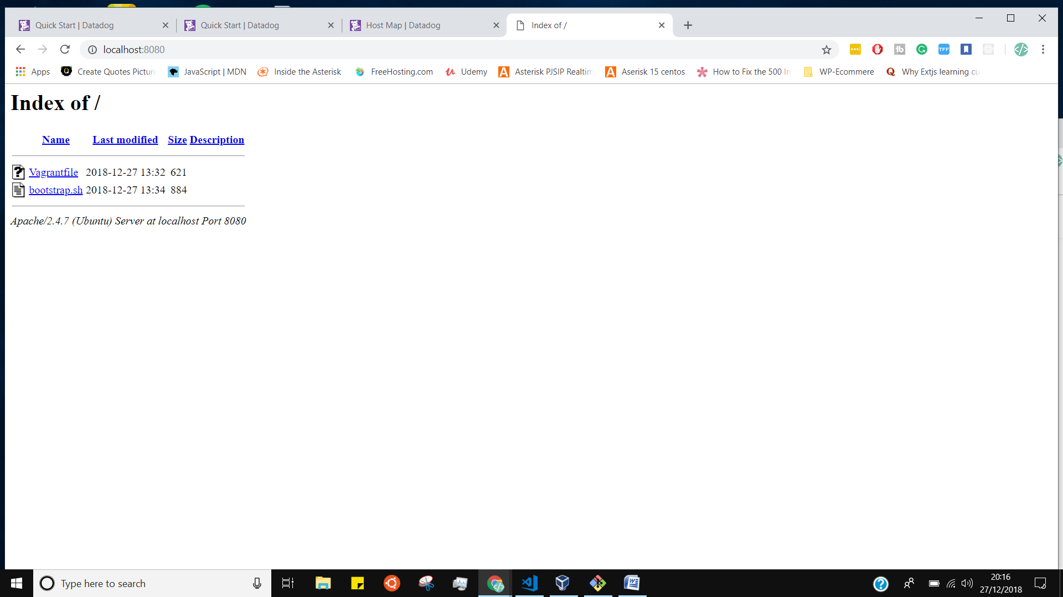

**Start up the vagrant**

**Vagrant reload**

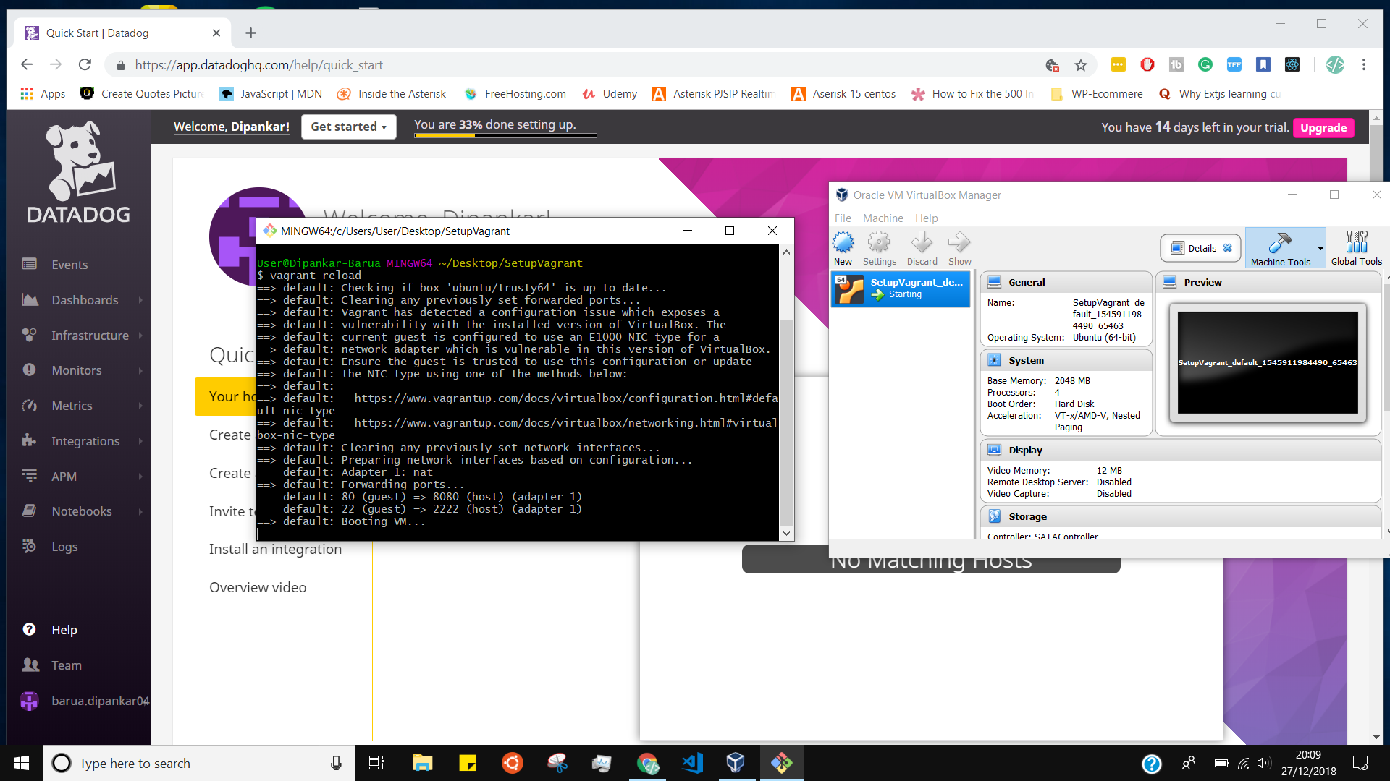

**Connecte ssh**

**Vagrant ssh**



**Sign up for Data dog:**

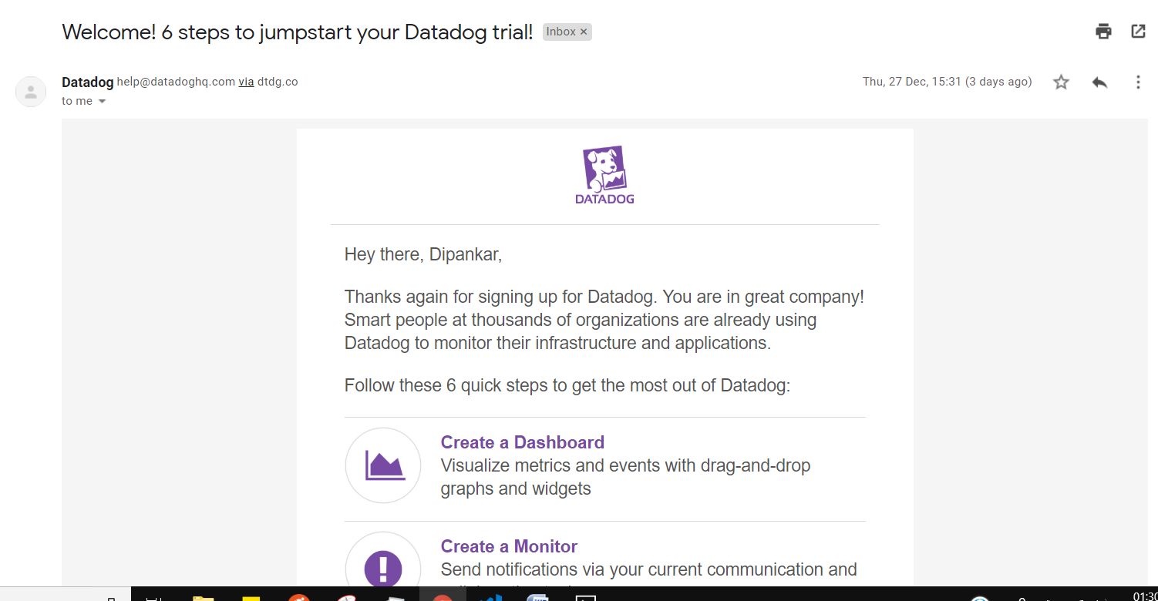

**1,2.Containerized approach with Docker for Linux and our dockerized Datadog Agent image**

**The Datadog agent was successfully installed via the following:**

**We can install two ways: First one is recommended**

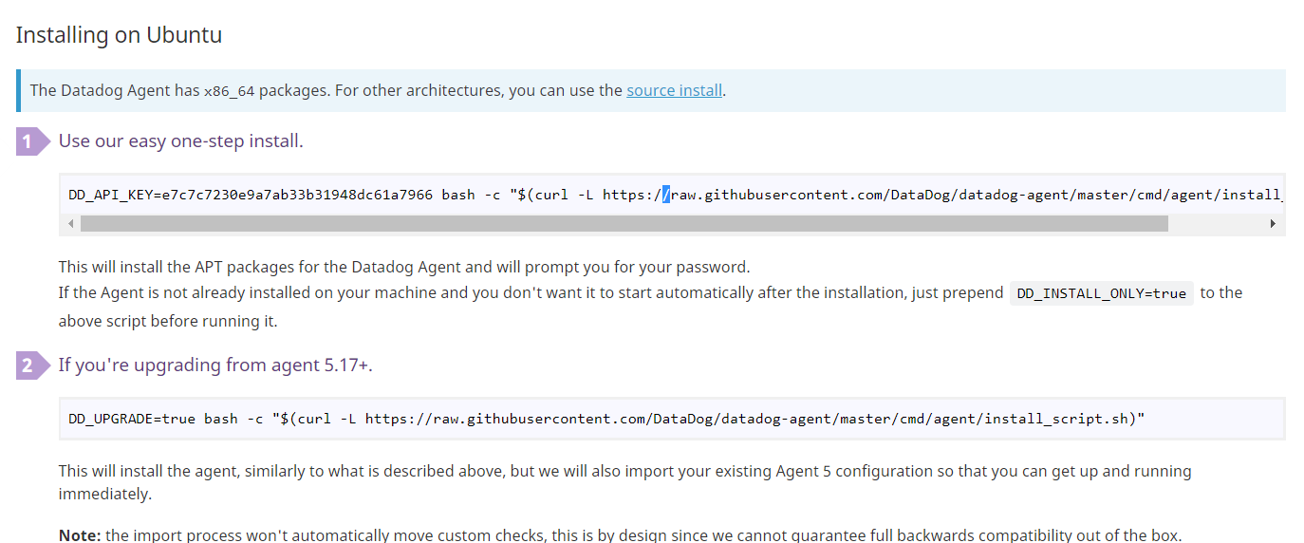

DD_API_KEY=610080f148d9e4d47efed7c611e64d7d bash -c "$(curl -L <https://raw.githubusercontent.com/DataDog/datadog-agent/master/cmd/agent/install_script.sh>)"

**Next one is step by step Process**

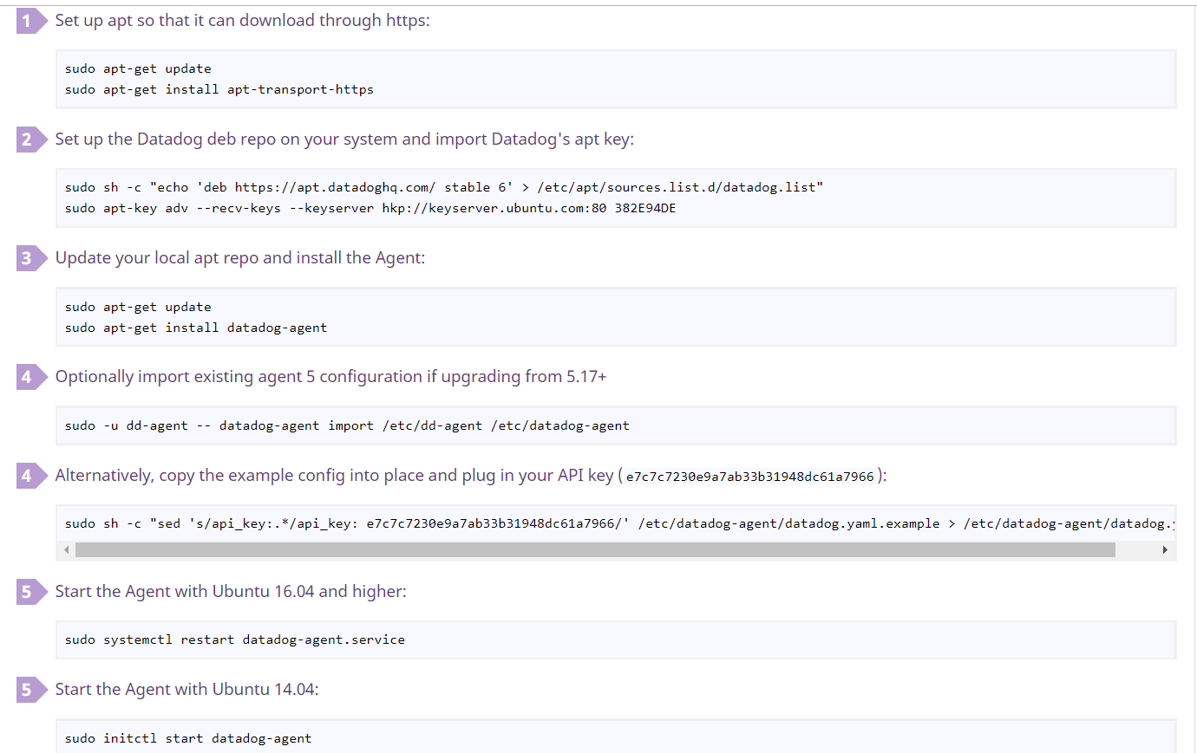

**1.3Datadog Container Docker Install by following command**

**docker run -d --name dd-agent -v /var/run/docker.sock:/var/run/docker.sock:ro -v /proc/:/host/proc/:ro -v /sys/fs/cgroup/:/host/sys/fs/cgroup:ro -e DD_API_KEY=610080f148d9e4d47efed7c611e64d7d datadog/agent:latest**

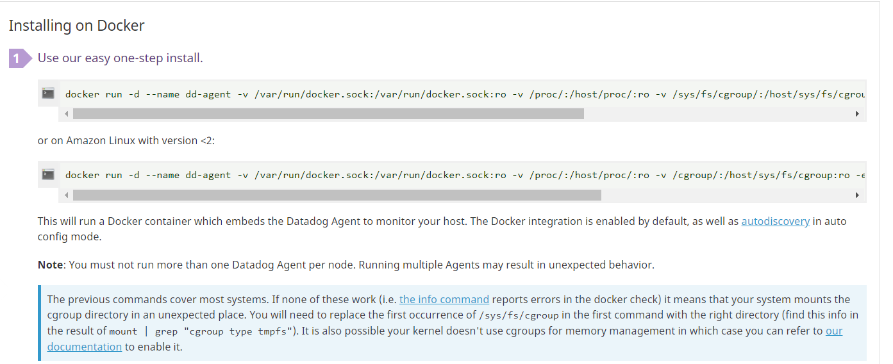

vagrant@ubuntu-xenial:~$ sudo docker run -d --name dd-agent -v /var/run/docker.sock:/var/run/docker.sock:ro -v /proc/:/host/proc/:ro -v /sys/fs/cgroup/:/host/sys/fs/cgroup:ro -e DD_API_KEY=610080f148d9e4d47efed7c611e64d7d datadog/agent:latest

Unable to find image 'datadog/agent:latest' locally

latest: Pulling from datadog/agent

790c37dedd62: Pull complete

289cb409a94c: Pull complete

c8c8c4faaf9e: Pull complete

237fb89e1ed6: Pull complete

f57b386ca81e: Pull complete

847930fc0785: Pull complete

dc7a1564846a: Pull complete

2f9394a89b51: Pull complete

Digest: sha256:301adad25c80a2d976c47f77b5341479cf0e5f2f81db353c90568e8c42ab6576

Status: Downloaded newer image for datadog/agent:latest

6ee6039e47b205ea357fb9485ca04ddf99a48581b9c1dd7736cf59a56844a2bd

vagrant@ubuntu-xenial:~$

**Is Datadog is running or not to know I run the command below**

sudo datadog-agent status

**logs:**

Welcome to Ubuntu 14.04.5 LTS (GNU/Linux 3.13.0-163-generic x86_64)

* Documentation: https://help.ubuntu.com/

System information as of Thu Dec 27 19:14:59 UTC 2018

System load: 0.42 Processes: 130

Usage of /: 5.0% of 39.34GB Users logged in: 0

Memory usage: 7% IP address for eth0: 10.0.2.15

Swap usage: 0%

Graph this data and manage this system at:

https://landscape.canonical.com/

Get cloud support with Ubuntu Advantage Cloud Guest:

http://www.ubuntu.com/business/services/cloud

New release '16.04.5 LTS' available.

Run 'do-release-upgrade' to upgrade to it.

Last login: Thu Dec 27 19:11:01 2018 from 10.0.2.2

vagrant@vagrant-ubuntu-trusty-64:~$ sudo datadog-agent status

Getting the status from the agent.

==============

Agent (v6.8.2)

==============

Status date: 2018-12-27 19:18:12.131384 UTC

Pid: 872

Python Version: 2.7.15

Logs:

Check Runners: 4

Log Level: info

Paths

=====

Config File: /etc/datadog-agent/datadog.yaml

conf.d: /etc/datadog-agent/conf.d

checks.d: /etc/datadog-agent/checks.d

Clocks

======

NTP offset: 350µs

System UTC time: 2018-12-27 19:18:12.131384 UTC

Host Info

=========

bootTime: 2018-12-27 19:14:44.000000 UTC

kernelVersion: 3.13.0-163-generic

os: linux

platform: ubuntu

platformFamily: debian

platformVersion: 14.04

procs: 187

uptime: 16s

virtualizationRole: guest

virtualizationSystem: vbox

Hostnames

=========

hostname: vagrant-ubuntu-trusty-64

socket-fqdn: vagrant-ubuntu-trusty-64

socket-hostname: vagrant-ubuntu-trusty-64

hostname provider: os

unused hostname providers:

aws: not retrieving hostname from AWS: the host is not an ECS instance, and other providers already retrieve non-default hostnames

configuration/environment: hostname is empty

gce: unable to retrieve hostname from GCE: Get http://169.254.169.254/computeMetadata/v1/instance/hostname: dial tcp 169.254.169.254:80: connect: network is unreachable

=========

Collector

=========

Running Checks

==============

cpu

---

Instance ID: cpu [OK]

Total Runs: 13

Metric Samples: Last Run: 6, Total: 72

Events: Last Run: 0, Total: 0

Service Checks: Last Run: 0, Total: 0

Average Execution Time : 0s

disk (2.0.0)

------------

Instance ID: disk:e5dffb8bef24336f [OK]

Total Runs: 13

Metric Samples: Last Run: 84, Total: 1,092

Events: Last Run: 0, Total: 0

Service Checks: Last Run: 0, Total: 0

Average Execution Time : 99ms

file_handle

-----------

Instance ID: file_handle [OK]

Total Runs: 12

Metric Samples: Last Run: 5, Total: 60

Events: Last Run: 0, Total: 0

Service Checks: Last Run: 0, Total: 0

Average Execution Time : 0s

io

--

Instance ID: io [OK]

Total Runs: 13

Metric Samples: Last Run: 26, Total: 320

Events: Last Run: 0, Total: 0

Service Checks: Last Run: 0, Total: 0

Average Execution Time : 14ms

load

----

Instance ID: load [OK]

Total Runs: 12

Metric Samples: Last Run: 6, Total: 72

Events: Last Run: 0, Total: 0

Service Checks: Last Run: 0, Total: 0

Average Execution Time : 0s

memory

------

Instance ID: memory [OK]

Total Runs: 13

Metric Samples: Last Run: 17, Total: 221

Events: Last Run: 0, Total: 0

Service Checks: Last Run: 0, Total: 0

Average Execution Time : 1ms

network (1.8.0)

---------------

Instance ID: network:2a218184ebe03606 [OK]

Total Runs: 12

Metric Samples: Last Run: 20, Total: 240

Events: Last Run: 0, Total: 0

Service Checks: Last Run: 0, Total: 0

Average Execution Time : 3ms

ntp

---

Instance ID: ntp:b4579e02d1981c12 [OK]

Total Runs: 13

Metric Samples: Last Run: 1, Total: 13

Events: Last Run: 0, Total: 0

Service Checks: Last Run: 1, Total: 13

Average Execution Time : 18ms

uptime

------

Instance ID: uptime [OK]

Total Runs: 12

Metric Samples: Last Run: 1, Total: 12

Events: Last Run: 0, Total: 0

Service Checks: Last Run: 0, Total: 0

Average Execution Time : 0s

========

JMXFetch

========

Initialized checks

==================

no checks

Failed checks

=============

no checks

=========

Forwarder

=========

Transactions

============

CheckRunsV1: 12

Dropped: 0

DroppedOnInput: 0

Events: 0

HostMetadata: 0

IntakeV1: 2

Metadata: 0

Requeued: 0

Retried: 0

RetryQueueSize: 0

Series: 0

ServiceChecks: 0

SketchSeries: 0

Success: 26

TimeseriesV1: 12

API Keys status

===============

API key ending with 64d7d on endpoint https://app.datadoghq.com: API Key valid

==========

Logs Agent

==========

Logs Agent is not running

=========

Aggregator

=========

Checks Metric Sample: 2,303

Dogstatsd Metric Sample: 154

Event: 1

Events Flushed: 1

Number Of Flushes: 12

Series Flushed: 2,122

Service Check: 114

Service Checks Flushed: 119

=========

DogStatsD

=========

Event Packets: 0

Event Parse Errors: 0

Metric Packets: 154

Metric Parse Errors: 0

Service Check Packets: 0

Service Check Parse Errors: 0

**To get the related info of Datadog agent we can use below command**

| **DESCRIPTION** | **COMMAND** |
| --- | --- |
| Start Agent as a service | sudo service datadog-agent start |
| Stop Agent running as a service | sudo service datadog-agent stop |
| Restart Agent running as a service | sudo service datadog-agent restart |
| Status of Agent service | sudo service datadog-agent status |
| Status page of running Agent | sudo datadog-agent status |
| Send flare | sudo datadog-agent flare |
| Display command usage | sudo datadog-agent --help |
| Run a check | sudo -u dd-agent -- datadog-agent check <check_name> |

**I already install all the necessary packages those are all in vagrant provision shell script**.

**To get the MySQL config file change the directory**

[vagrant@vagrant-ubuntu-trusty-64:/etc/datadog-agent/conf.d$](mailto:vagrant@vagrant-ubuntu-trusty-64:/etc/datadog-agent/conf.d$)

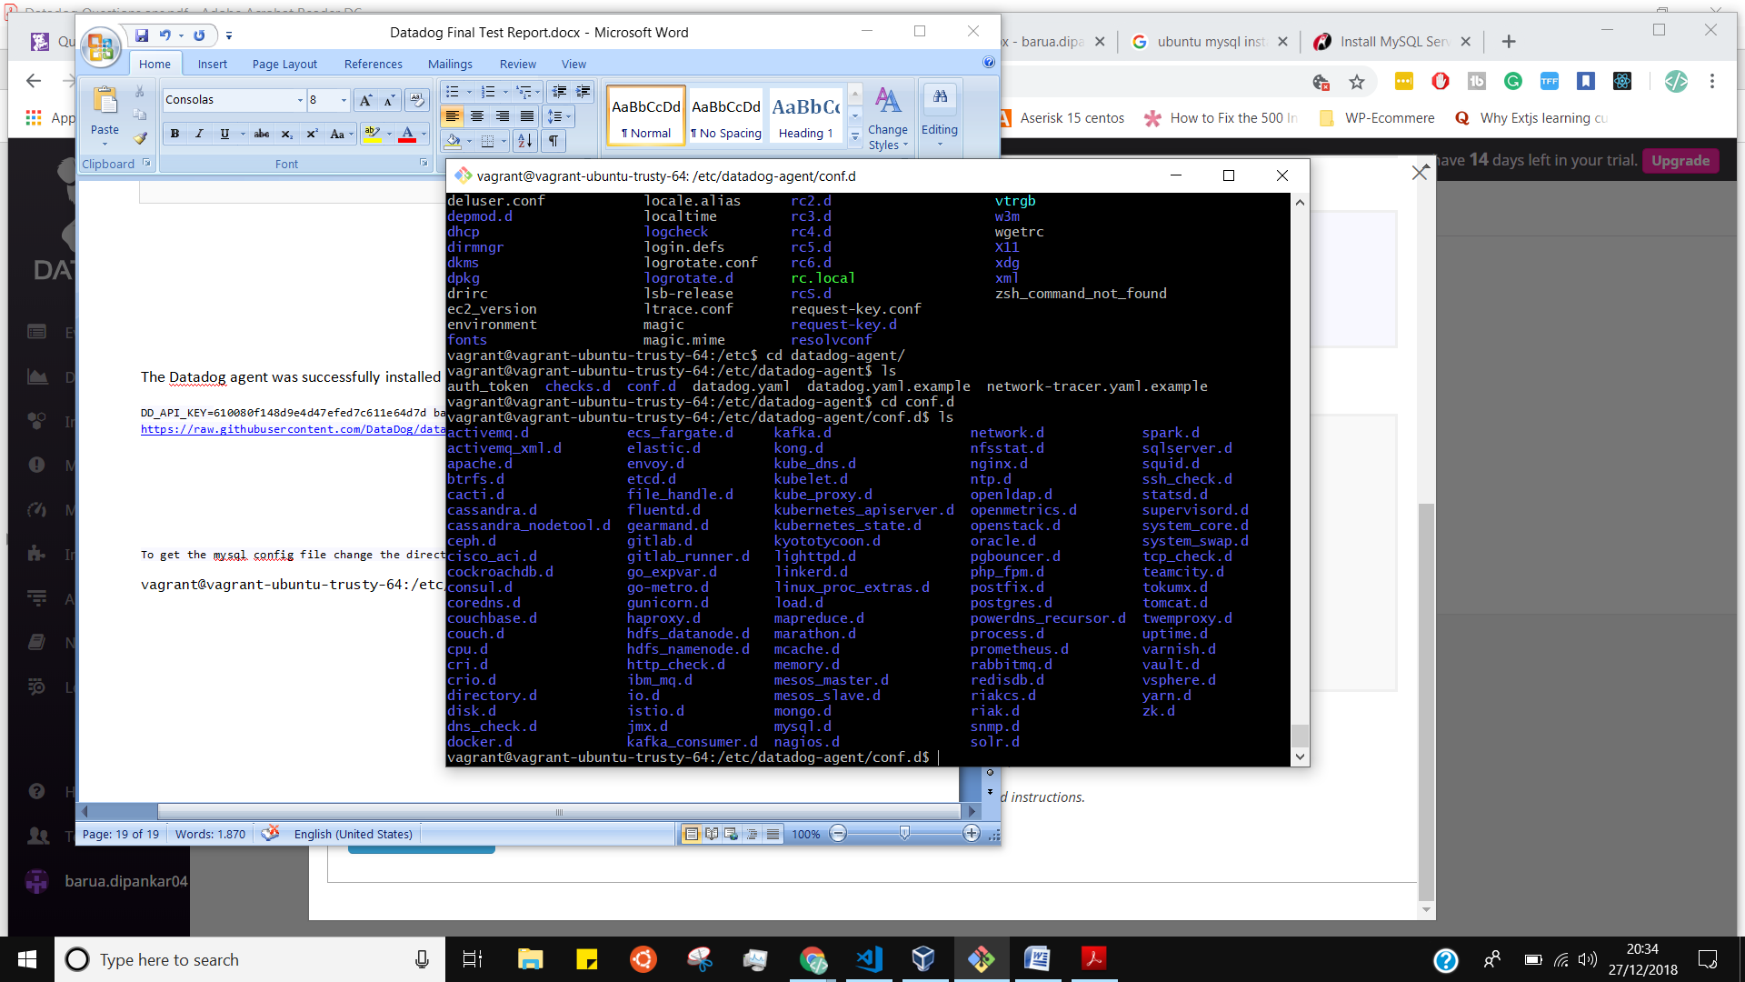

**And also install manually MySQL integrations.**

After installing the MySQL integration I restart my datadog agent

by following command

**sudo service datadog-agent restart**

logs

vagrant@vagrant-ubuntu-trusty-64:/etc/datadog-agent/conf.d/mysql.d$ cd

vagrant@vagrant-ubuntu-trusty-64:~$ sudo service datadog-agent restart

datadog-agent stop/waiting

datadog-agent start/running, process 9504

vagrant@vagrant-ubuntu-trusty-64:~$

vagrant@vagrant-ubuntu-trusty-64:~$ sudo service datadog-agent restart

datadog-agent stop/waiting

datadog-agent start/running, process 9712

**Collecting Metrics:**

**Mysql**

sudo mysql -u root -p

**I used this Documents to create new user with password;**

[**https://docs.datadoghq.com/integrations/mysql/**](https://docs.datadoghq.com/integrations/mysql/)

### [Configuration](https://docs.datadoghq.com/integrations/mysql/#configuration)

Edit conf.d/mysql.d/conf.yaml in the root of your [Agent’s configuration directory](https://docs.datadoghq.com/agent/faq/agent-configuration-files/#agent-configuration-directory) in order to connect the Agent to your MySQL server. You will begin collecting your MySQL [metrics](https://docs.datadoghq.com/integrations/mysql/#metric-collection) and [logs](https://docs.datadoghq.com/integrations/mysql/#log-collection) right away. See the [sample configuration file](https://github.com/DataDog/integrations-core/blob/master/mysql/datadog_checks/mysql/data/conf.yaml.example)for all available configuration options.

#### [PREPARE MYSQL](https://docs.datadoghq.com/integrations/mysql/#prepare-mysql)

On each MySQL server, create a database user for the Datadog Agent:

mysql> CREATE USER 'datadog'@'localhost' IDENTIFIED BY '<UNIQUEPASSWORD>';

Query OK, 0 rows affected (0.00 sec)

For mySQL 8.0+ create the datadog user with the native password hashing method:

mysql> CREATE USER 'datadog'@'localhost' IDENTIFIED WITH mysql_native_password by '<UNIQUEPASSWORD>';

Query OK, 0 rows affected (0.00 sec)

**sudo mysql -e "CREATE USER 'datadog'@'localhost' IDENTIFIED BY 'datadog';"**

**CREATE USER 'datadog'@'localhost' IDENTIFIED BY 'datadog';**

**GRANT PROCESS ON *.* TO 'datadog'@'localhost';**

**I gave user is datadog and password also datadog**

**Images:**

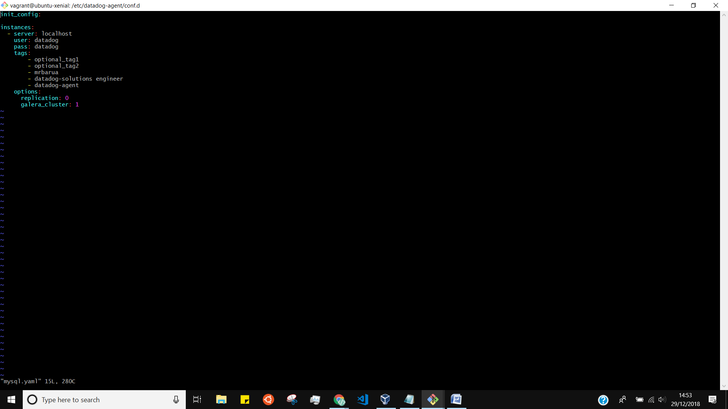

mysql config file

[vagrant@ubuntu-xenial:/etc/datadog-agent/conf.d/mysql.d$](mailto:vagrant@ubuntu-xenial:/etc/datadog-agent/conf.d/mysql.d$)

conf.yaml.example

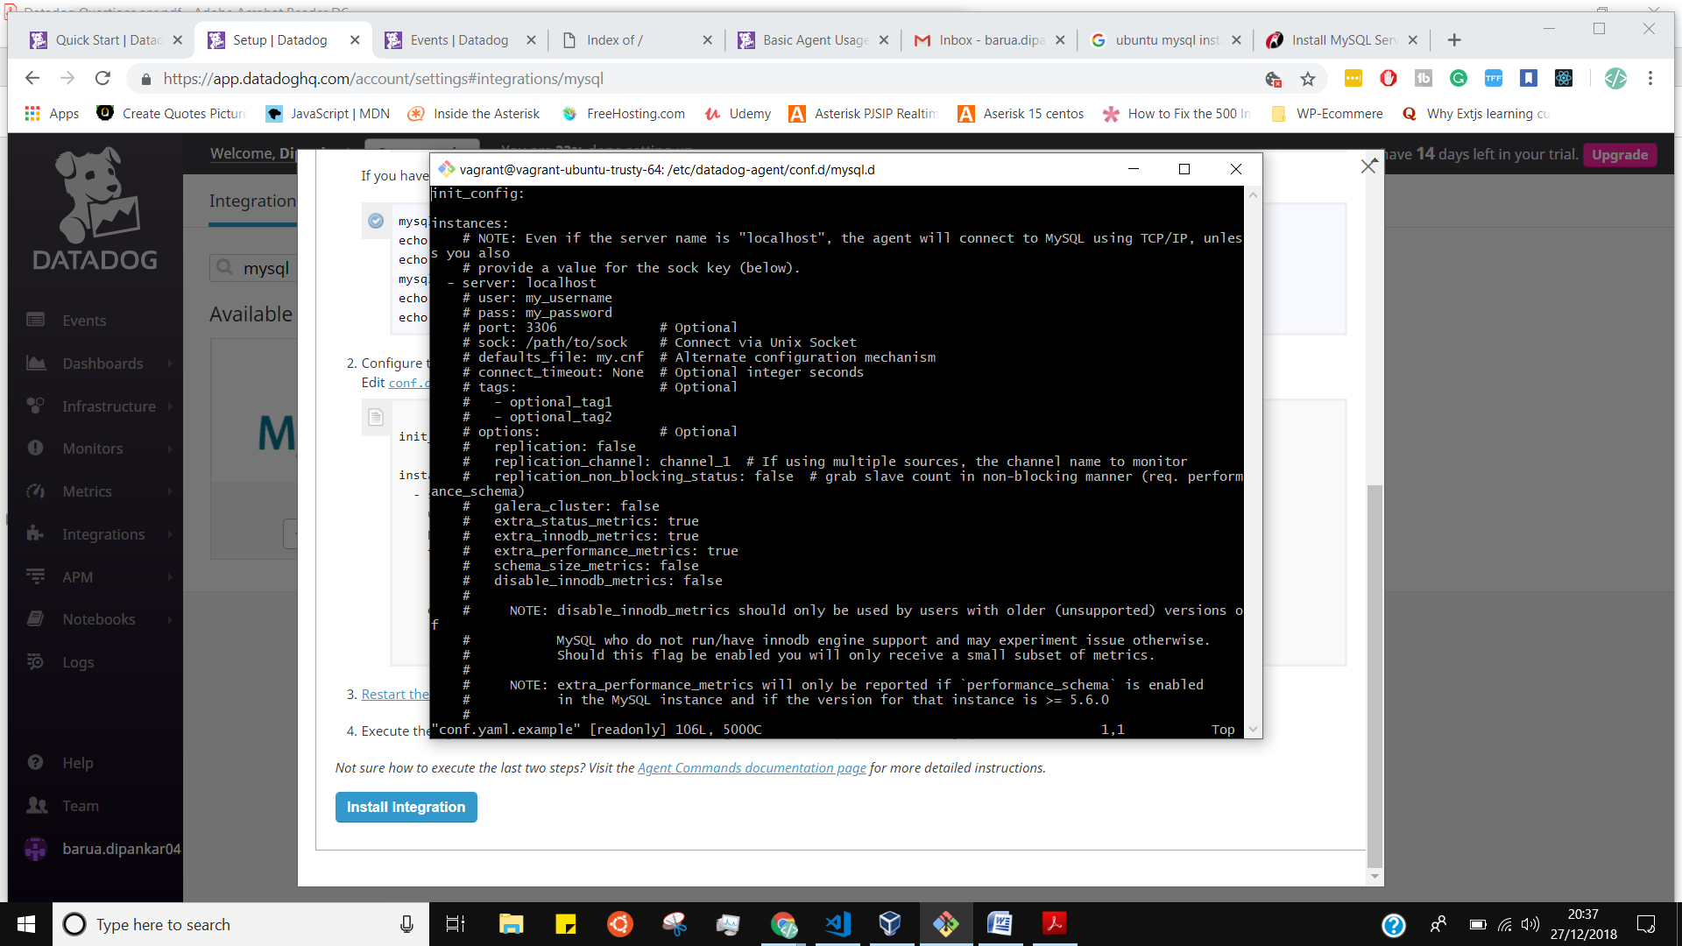

I Copied the example yaml file and as well create new file by following command

**Sudo cp conf.yaml.example mysql.yaml**

I took a lot of time because I was doing mistake

I was creating a file inside the mysql. d directory

/etc/datadog-agent/conf.d/mysql.d

But I had to create file inside the conf.d

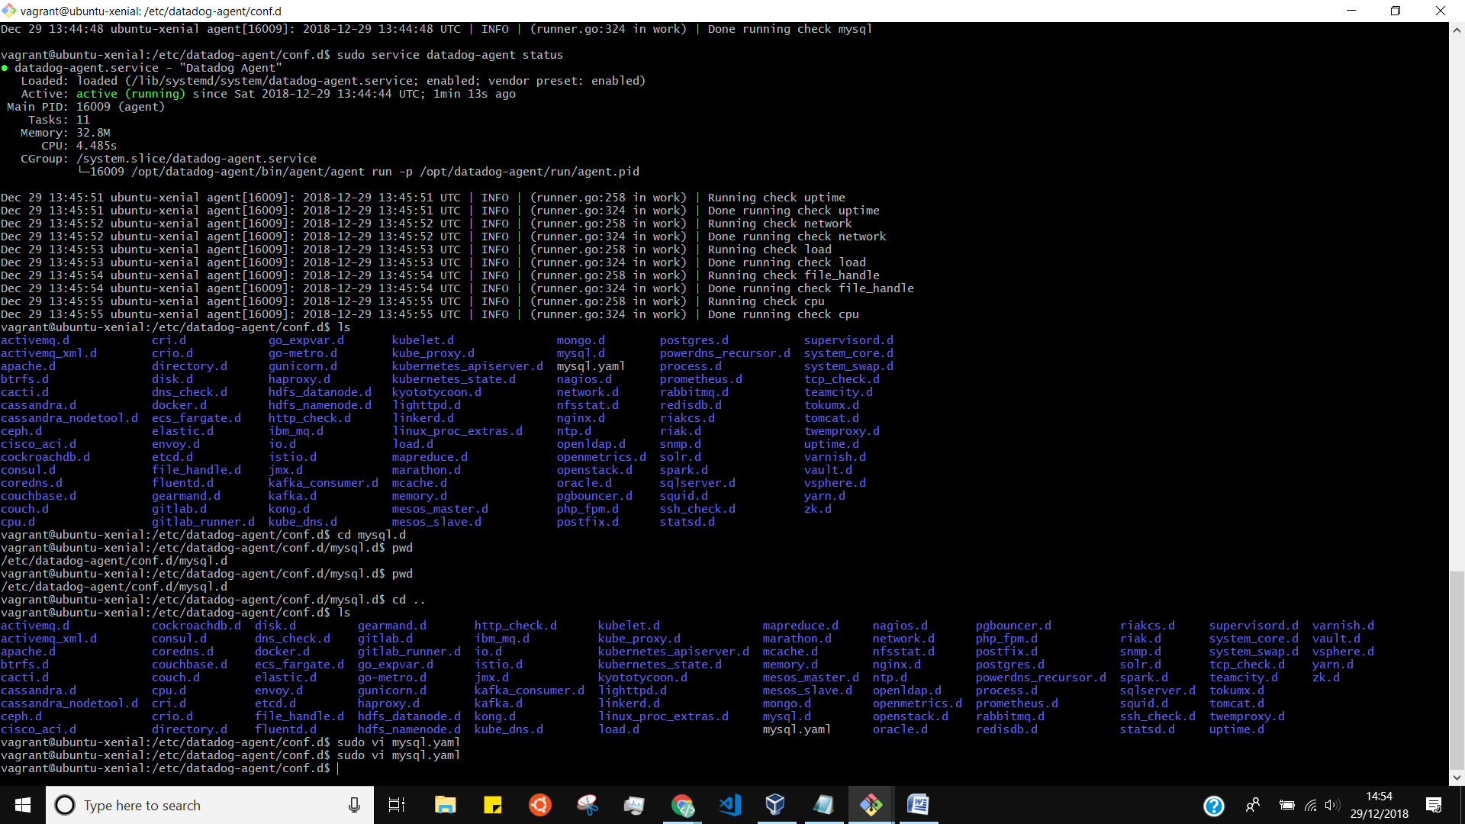



**dd tags in the Agent config file and show us a screenshot of your host and its tags on the Host Map page in Datadog**

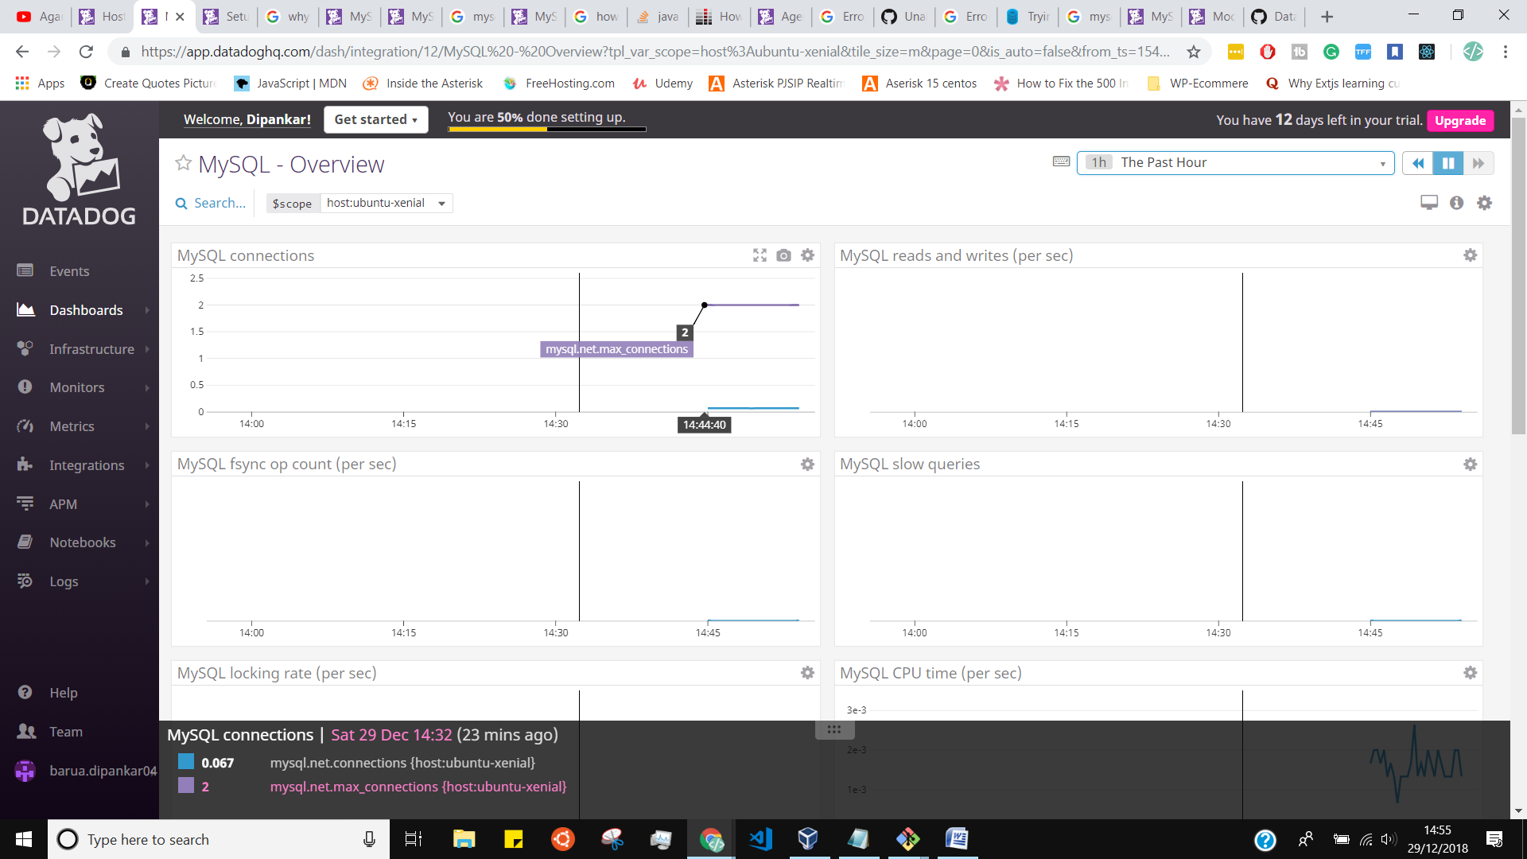

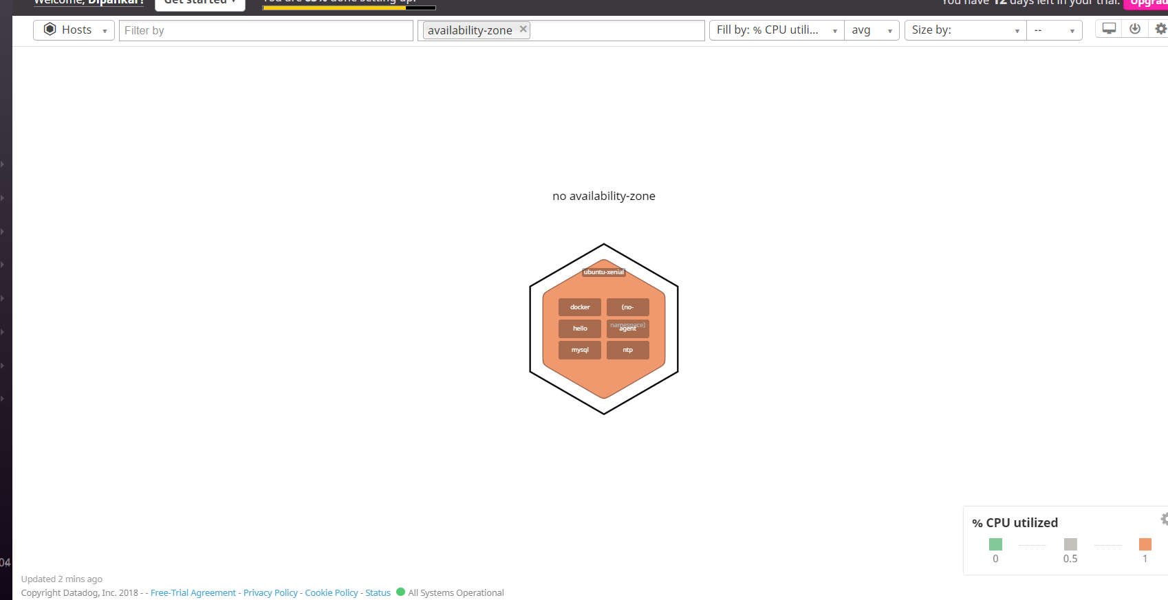

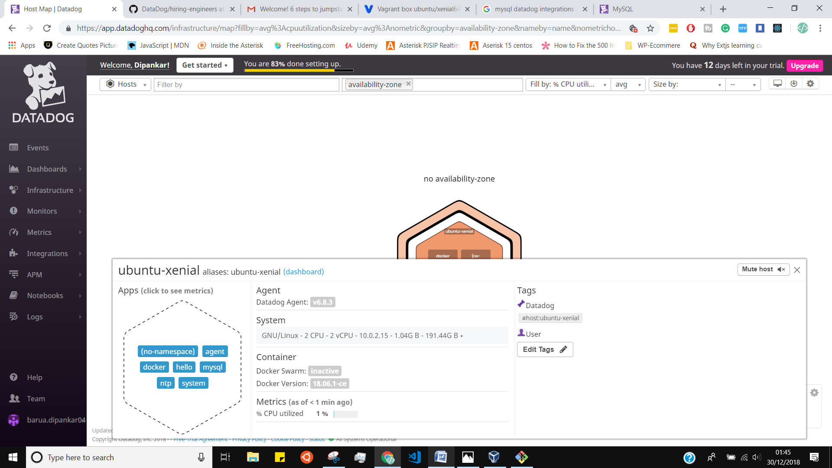

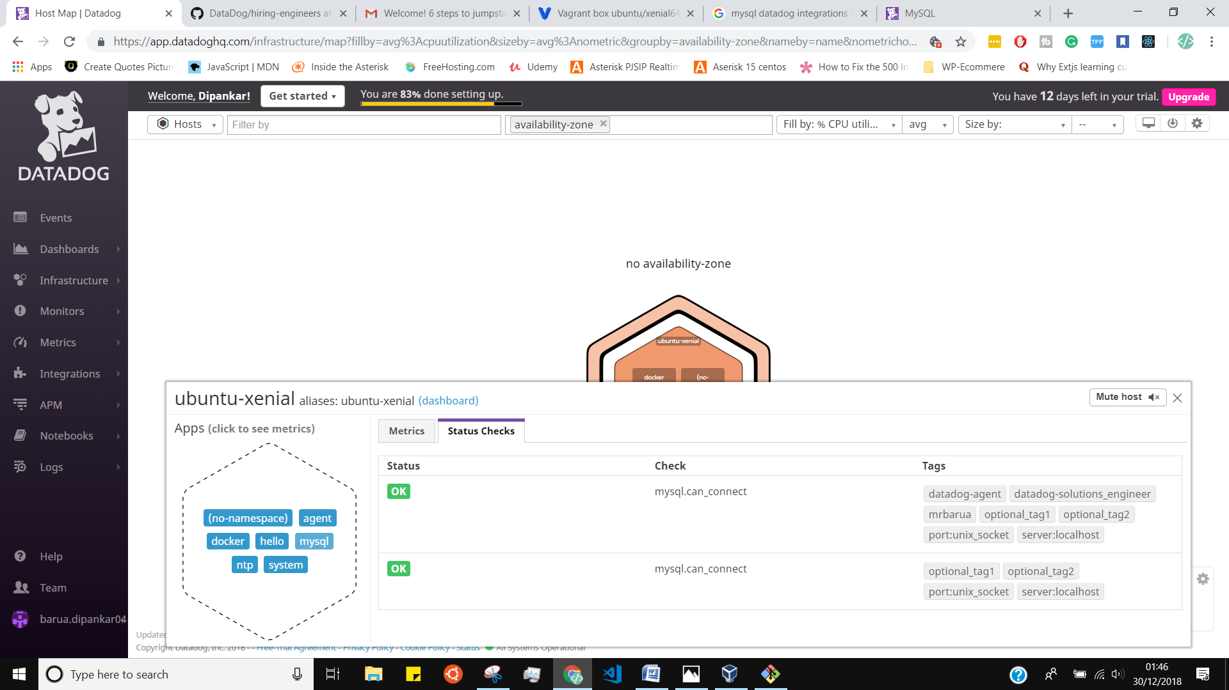

**Install a database on your machine (MongoDB, MySQL, or PostgreSQL) and then install the respective Datadog integration for that database.**

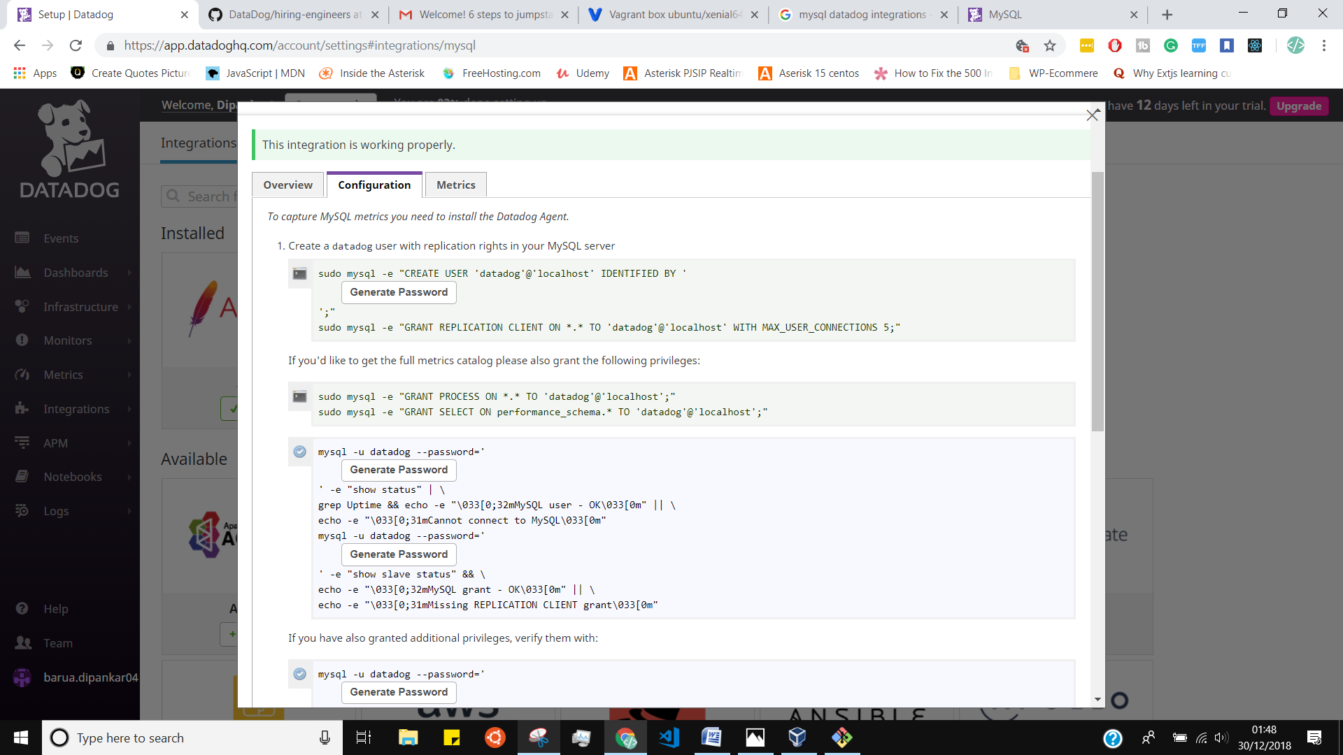

**Create a custom Agent check that submits a metric named my_metric with a random value between 0 and 1000**

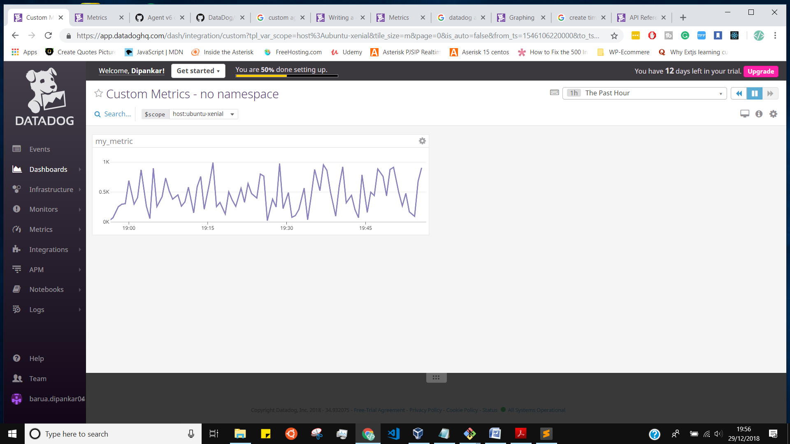

I created a Python file my_metric.py inside the checks.d directory

vagrant@ubuntu-xenial:/etc/datadog-agent$ cd checks.d

vagrant@ubuntu-xenial:/etc/datadog-agent/checks.d$ ls

dashboard-via-script.py flask-app.py my_metric.py my_metric.pyc

my_metric.py:

# the following try/except block will make the custom check compatible with any Agent version

try:

# first, try to import the base class from old versions of the Agent...

from checks import AgentCheck

except ImportError:

# ...if the above failed, the check is running in Agent version 6 or later

from datadog_checks.checks import AgentCheck

# content of the special variable __version__ will be shown in the Agent status page

__version__ = "1.0.0"

import random

class MyMetricCheck(AgentCheck):

def check(self, instance):

self.gauge('my_metric', random.randint(1,1001))

[vagrant@ubuntu-xenial:/etc/datadog-agent/checks.d$](mailto:vagrant@ubuntu-xenial:/etc/datadog-agent/checks.d$)

and as well yaml file a yaml file my_metric.yaml inside conf.d directory

[vagrant@ubuntu-xenial:/etc/datadog-agent/conf.d$](mailto:vagrant@ubuntu-xenial:/etc/datadog-agent/conf.d$)

my_metric.yaml:

init_config:

instances:

- min_collection_interval : 45

**Bonus Question Can you change the collection interval without modifying the Python check file you created?**

my_metric.yaml:

yes without changing Python file we can change interval inside the yaml file.

init_config:

instances:

- min_collection_interval : 45

Like instead of 45 we can setup 30

datadog-agent.service - "Datadog Agent"

Loaded: loaded (/lib/systemd/system/datadog-agent.service; enabled; vendor preset: enabled)

Active: active (running) since Sat 2018-12-29 02:47:08 UTC; 10s ago

Main PID: 9295 (agent)

Tasks: 11

Memory: 29.5M

CPU: 1.762s

CGroup: /system.slice/datadog-agent.service

└─9295 /opt/datadog-agent/bin/agent/agent run -p /opt/datadog-agent/run/agent.pid

Dec 29 02:47:13 ubuntu-xenial agent[9295]: 2018-12-29 02:47:13 UTC | INFO | (runner.go:324 in work) | Done running check uptime

Dec 29 02:47:14 ubuntu-xenial agent[9295]: 2018-12-29 02:47:14 UTC | INFO | (runner.go:258 in work) | Running check network

Dec 29 02:47:14 ubuntu-xenial agent[9295]: 2018-12-29 02:47:14 UTC | WARN | (datadog_agent.go:149 in LogMessage) | (base.py:228) | DEPRECATION NOTICE: `device_name` is deprecated, please use a `device:` tag in the

Dec 29 02:47:14 ubuntu-xenial agent[9295]: 2018-12-29 02:47:14 UTC | INFO | (runner.go:324 in work) | Done running check network

Dec 29 02:47:15 ubuntu-xenial agent[9295]: 2018-12-29 02:47:15 UTC | INFO | (runner.go:258 in work) | Running check load

Dec 29 02:47:15 ubuntu-xenial agent[9295]: 2018-12-29 02:47:15 UTC | INFO | (runner.go:324 in work) | Done running check load

Dec 29 02:47:16 ubuntu-xenial agent[9295]: 2018-12-29 02:47:16 UTC | INFO | (runner.go:258 in work) | Running check file_handle

Dec 29 02:47:16 ubuntu-xenial agent[9295]: 2018-12-29 02:47:16 UTC | INFO | (runner.go:324 in work) | Done running check file_handle

Dec 29 02:47:17 ubuntu-xenial agent[9295]: 2018-12-29 02:47:17 UTC | INFO | (runner.go:258 in work) | Running check cpu

Dec 29 02:47:17 ubuntu-xenial agent[9295]: 2018-12-29 02:47:17 UTC | INFO | (runner.go:324 in work) | Done running check cpu

lines 1-20/20 (END)

After running the check my_metric I got the Below logs:

vagrant@ubuntu-xenial:/etc/datadog-agent/checks.d$ sudo -u dd-agent -- datadog-agent check my_metric

=== Series ===

{

"series": [

{

"metric": "my_metric",

"points": [

[

1546105749,

615

]

],

"tags": null,

"host": "ubuntu-xenial",

"type": "gauge",

"interval": 0,

"source_type_name": "System"

}

]

}

=========

Collector

=========

Running Checks

==============

my_metric (1.0.0)

-----------------

Instance ID: my_metric:5bbfe9f3938f1c8d [OK]

Total Runs: 1

Metric Samples: Last Run: 1, Total: 1

Events: Last Run: 0, Total: 0

Service Checks: Last Run: 0, Total: 0

Average Execution Time : 0s

Check has run only once, if some metrics are missing you can try again with --check-rate to see any other metric if available.

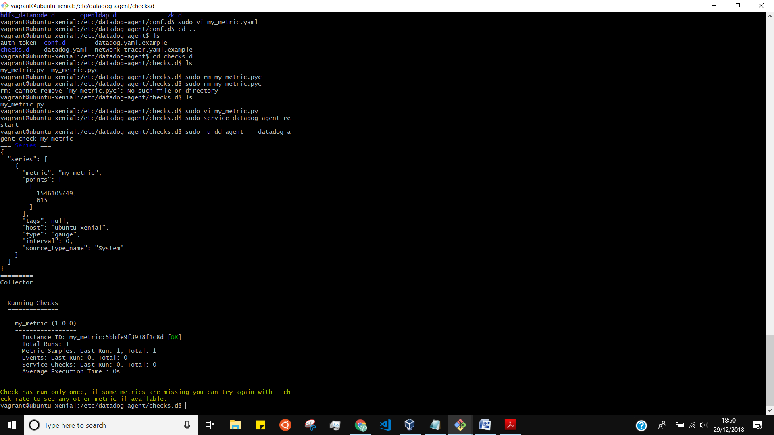

gent check my_metric

=== Series ===

{

"series": [

{

"metric": "my_metric",

"points": [

[

1546106211,

394

]

],

"tags": null,

"host": "ubuntu-xenial",

"type": "gauge",

"interval": 0,

"source_type_name": "System"

}

]

}

=========

Collector

=========

Running Checks

==============

my_metric (1.0.0)

-----------------

Instance ID: my_metric:5ba864f3937b5bad [OK]

Total Runs: 1

Metric Samples: Last Run: 1, Total: 1

Events: Last Run: 0, Total: 0

Service Checks: Last Run: 0, Total: 0

Average Execution Time : 0s

Check has run only once, if some metrics are missing you can try again with --check-rate to see any other metric if available.

vagrant@ubuntu-xenial:/etc/datadog-agent/checks.d$

Yes we can change the interval without modifying python file

init_config:

instances:

- min_collection_interval : 45

Here is yaml file into conf.d Directory

**Visualizing Data:**

<https://docs.datadoghq.com/api/?lang=python#create-a-timeboard>

**Utilize the Datadog API to create a Timeboard that contains**

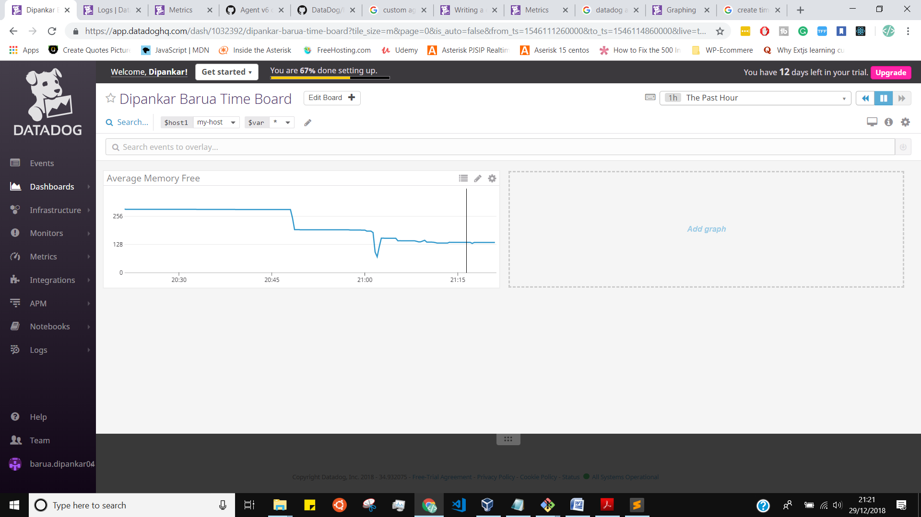

vagrant@ubuntu-xenial:/etc/datadog-agent$ cd checks.d

vagrant@ubuntu-xenial:/etc/datadog-agent/checks.d$ ls

dashboard-via-script.py flask-app.py my_metric.py my_metric.pyc

[vagrant@ubuntu-xenial:/etc/datadog-agent/checks.d$](mailto:vagrant@ubuntu-xenial:/etc/datadog-agent/checks.d$)

Inside the checks.d directory I created a python file name is dashboard-via-script.py

dashboard-via-script.py :

**Notes:  
Please be sure, when submitting your hiring challenge, to include the script that you've used to create this Timeboar**

**initialize(**options)**

**title = "Dipankar Barua Time Board"**

**description = "An informative timeboard."**

**graphs = [{**

**"definition": {**

**"events": [],**

**"requests": [**

**{"q": "avg:system.mem.free{*}"}**

**],**

**"viz": "timeseries"**

**},**

**"title": "Average Memory Free"**

**}]**

**template_variables = [{**

**"name": "host1",**

**"prefix": "host",**

**"default": "host:my-host"**

**}]**

**read_only = True**

**api.Timeboard.create(title=title,**

**description=description,**

**graphs=graphs,**

**template_variables=template_variables,**

**read_only=read_only)**

**I Have given the name Dipankar Barua Time Board"**

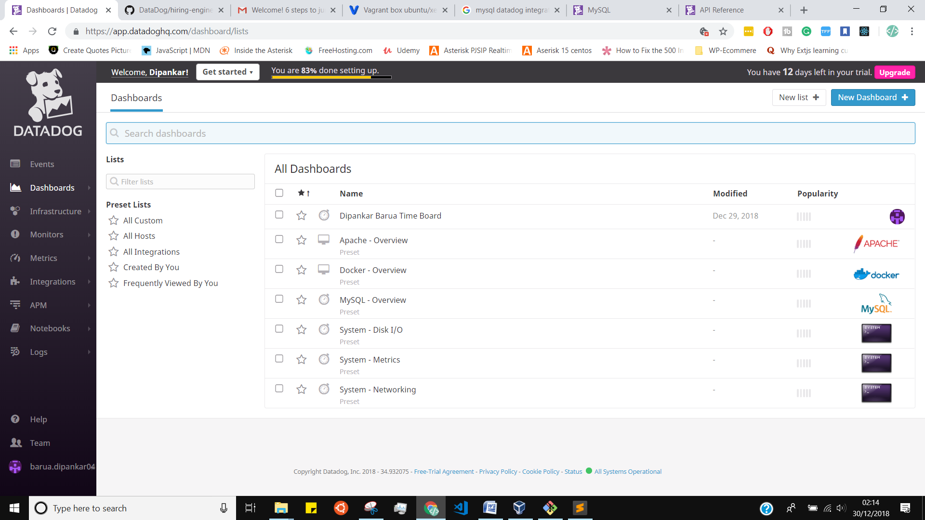

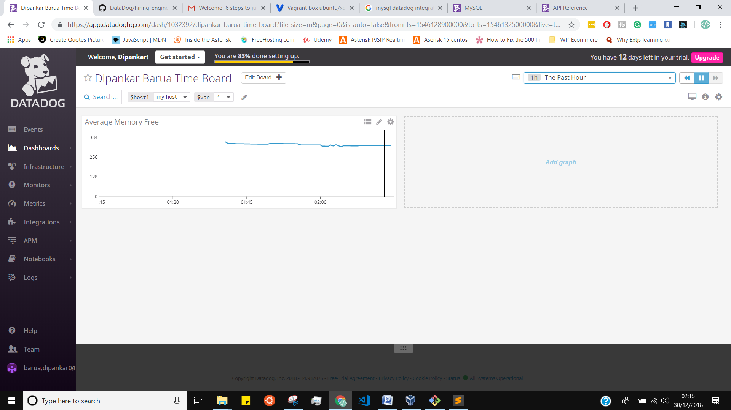

**Once this is created, access the Dashboard from your Dashboard List in the UI:**

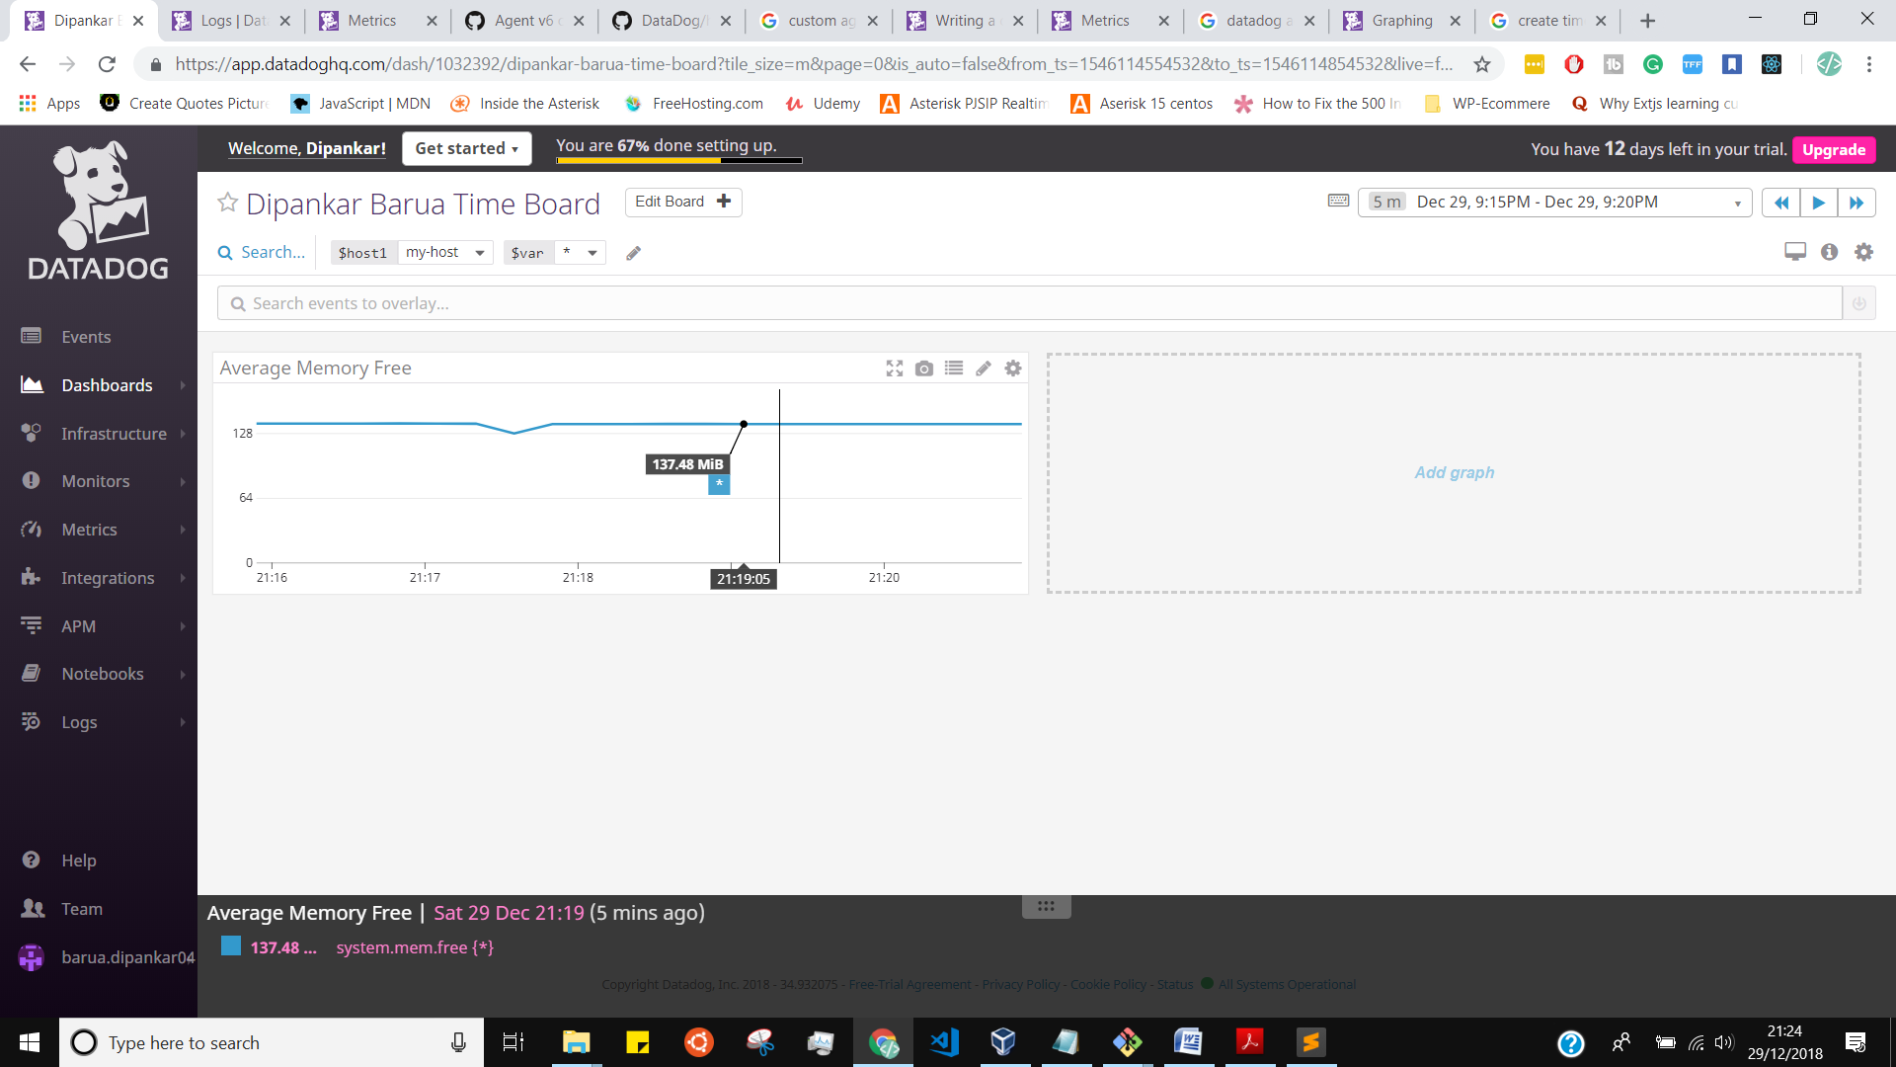

* **Set the Timeboard's timeframe to the past 5 minutes**
* **Take a snapshot of this graph and use the @ notation to send it to yourself.**
* 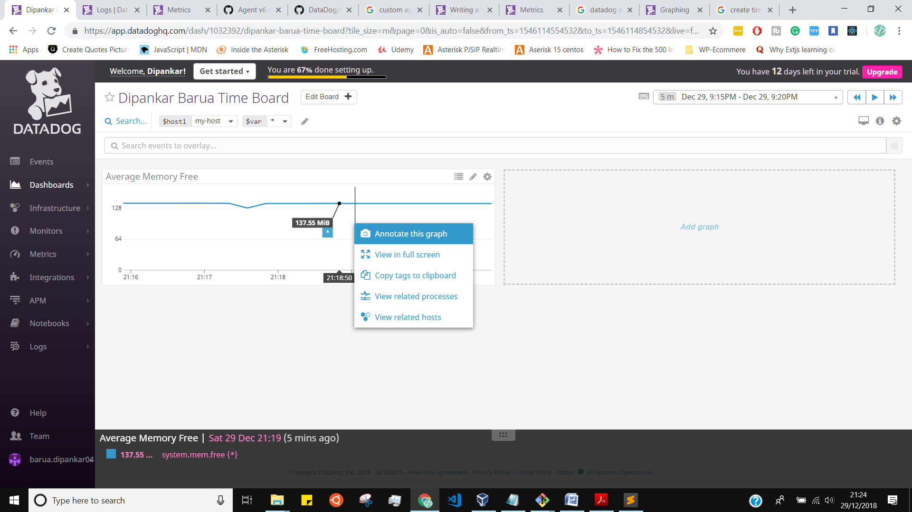
* 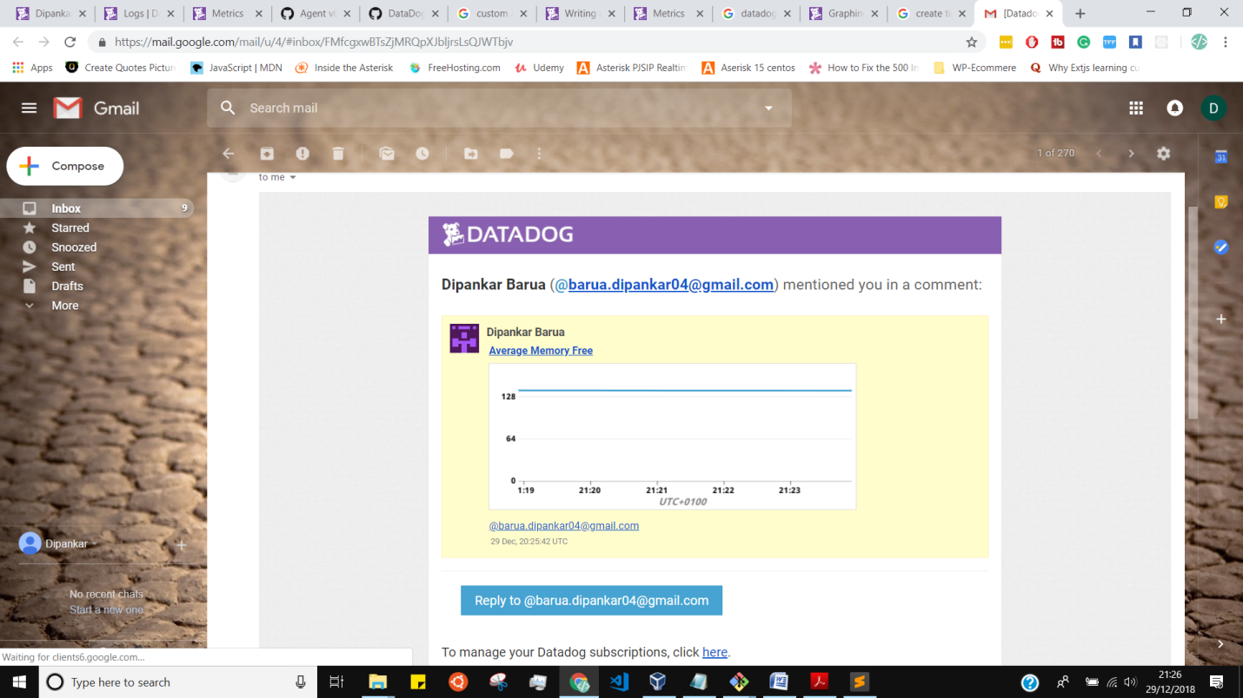
* **Bonus Question: What is the Anomaly graph displaying?**

The anomaly diagram is designed to show any variations in the data points from normal leaning. If the data point is outside of what is predicted, it's going to an anomaly.

**Monitoring Data**

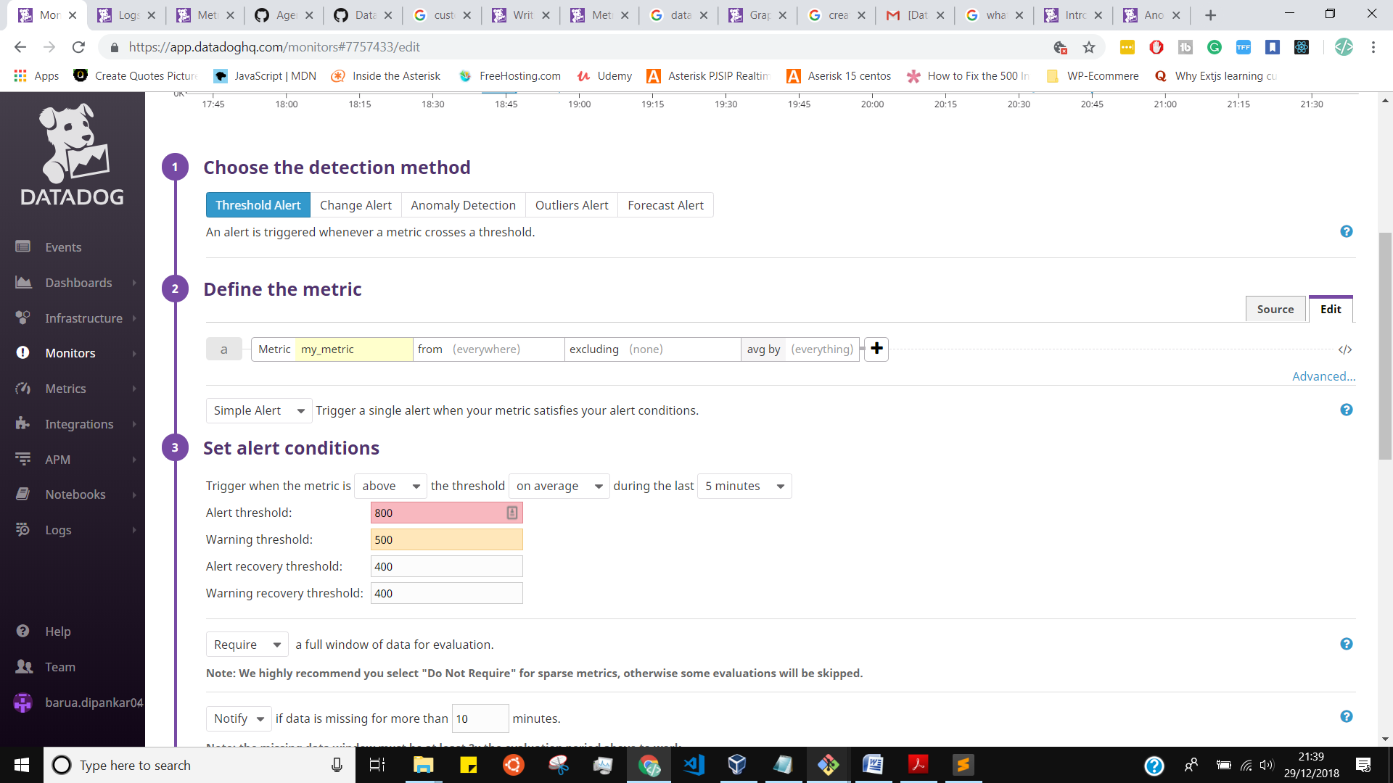

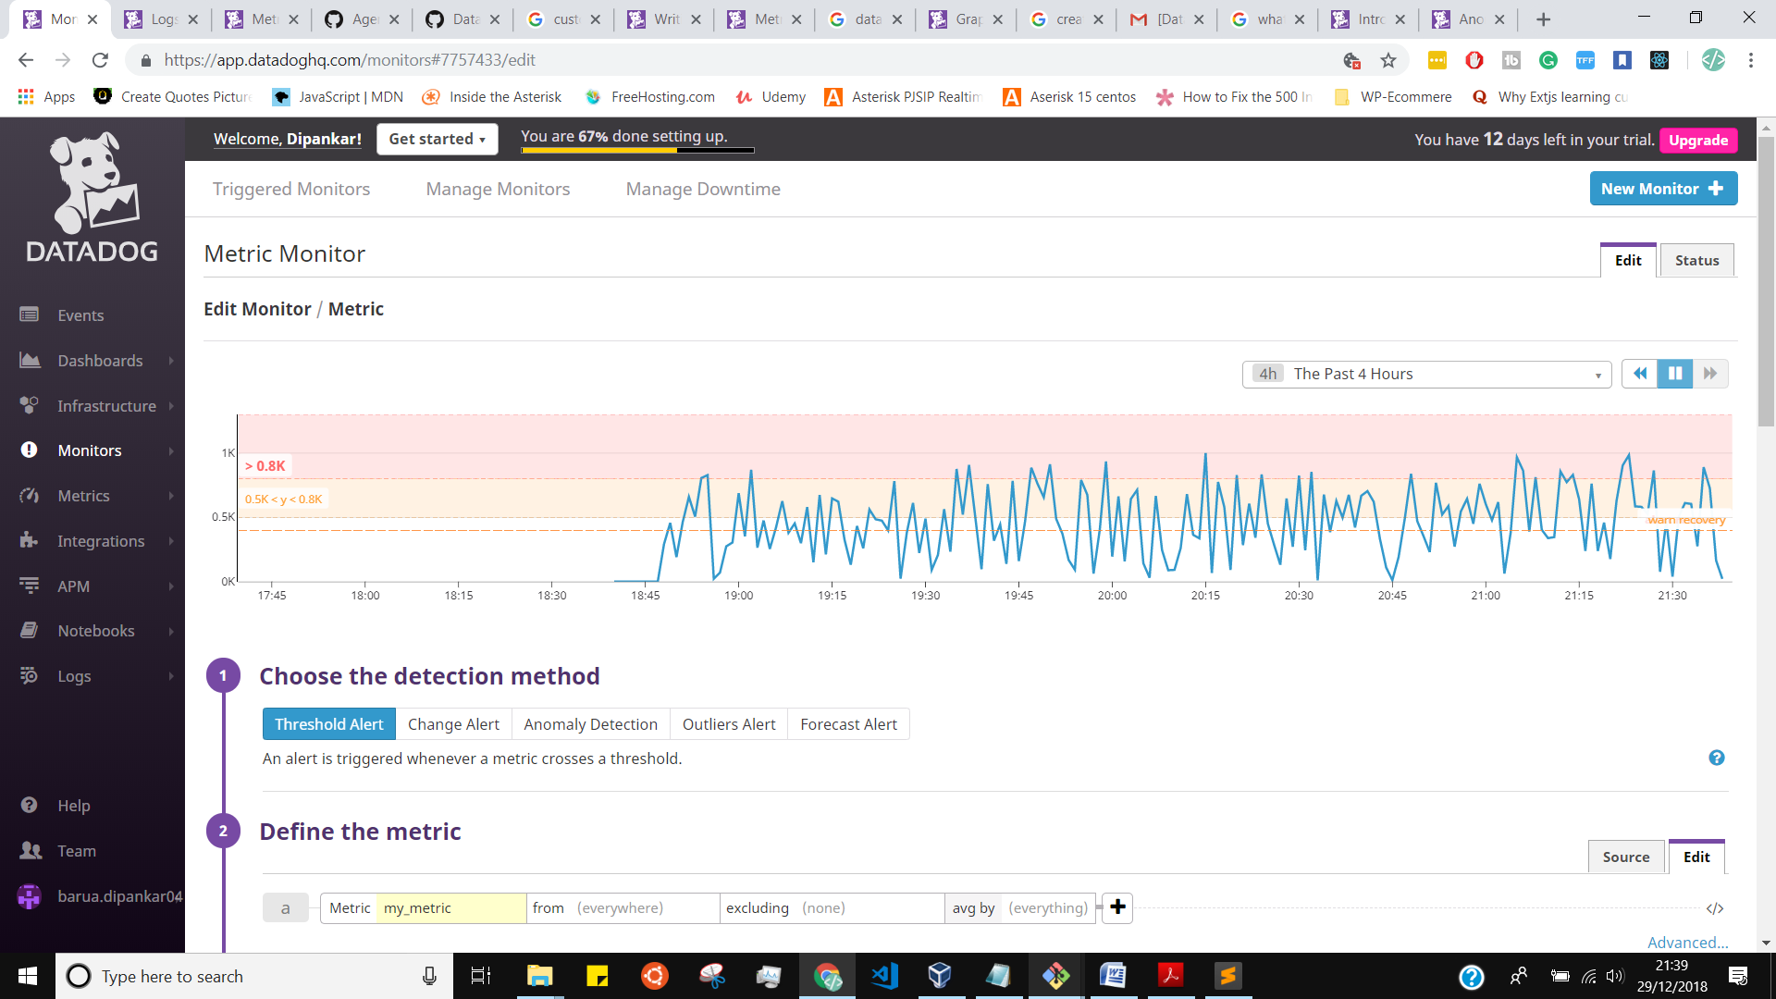

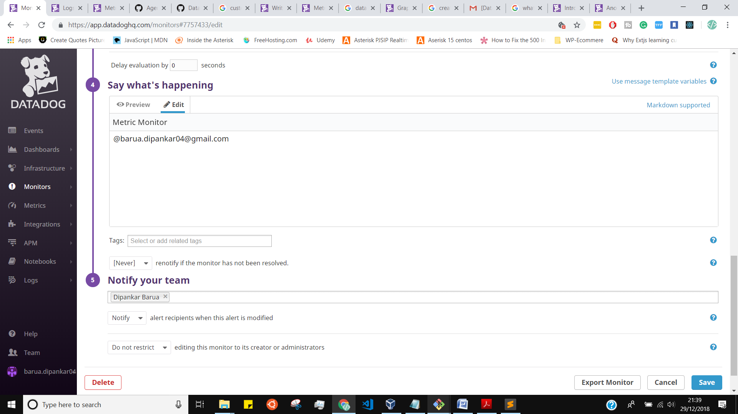

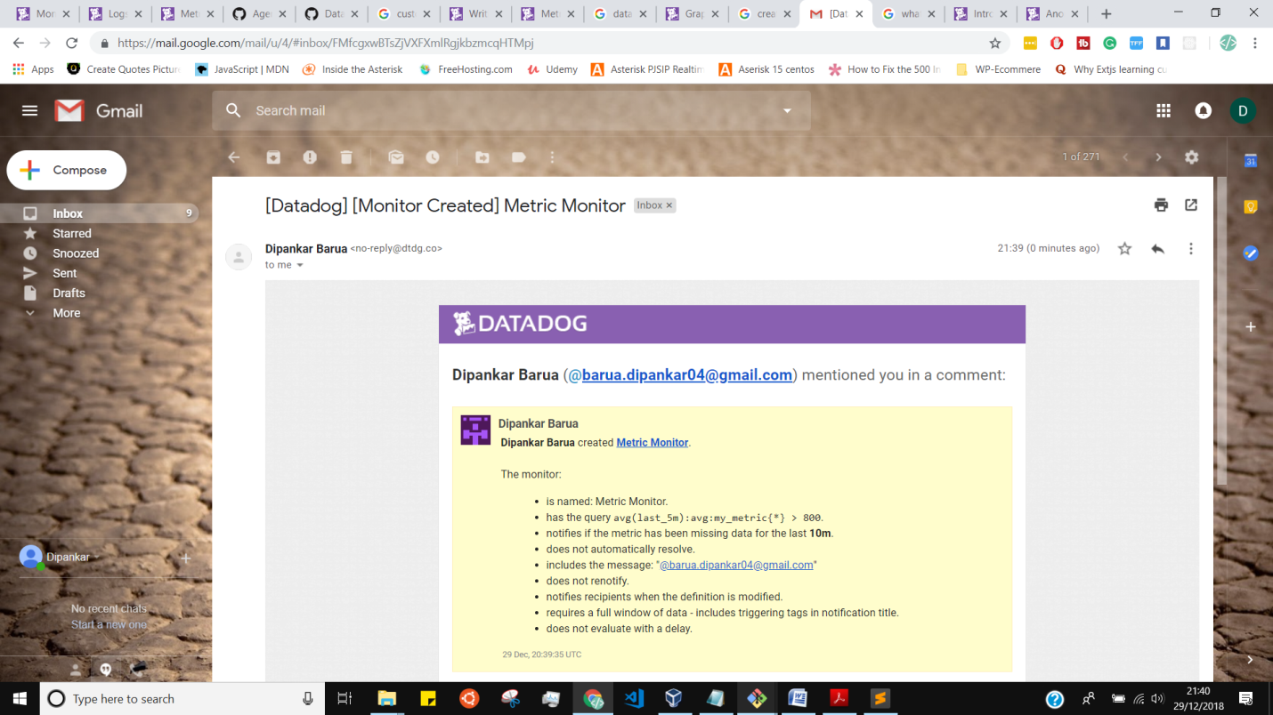

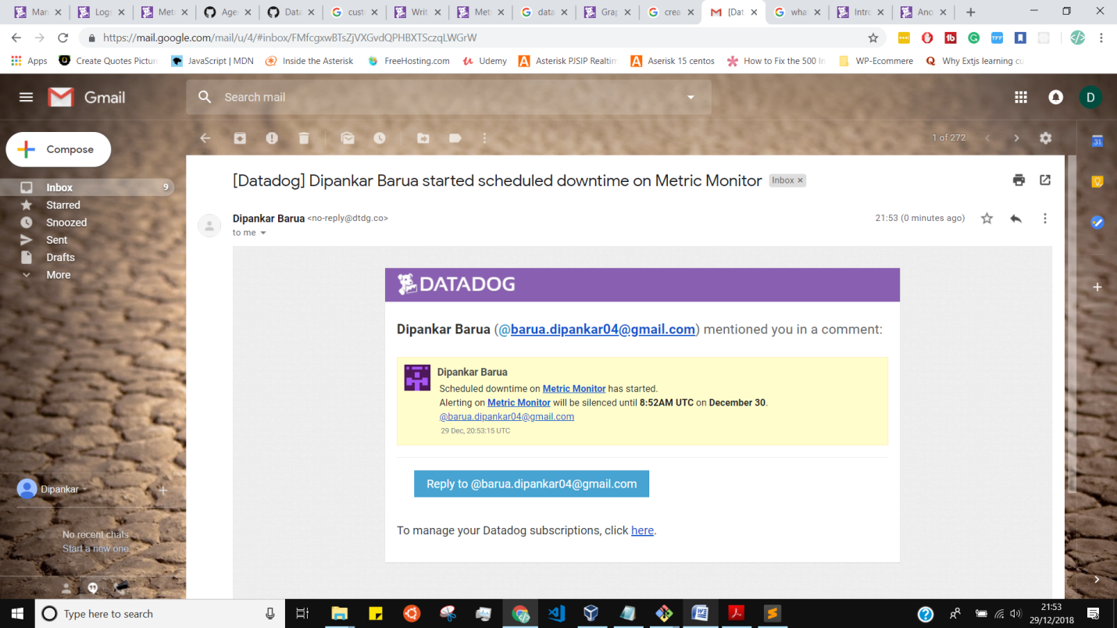

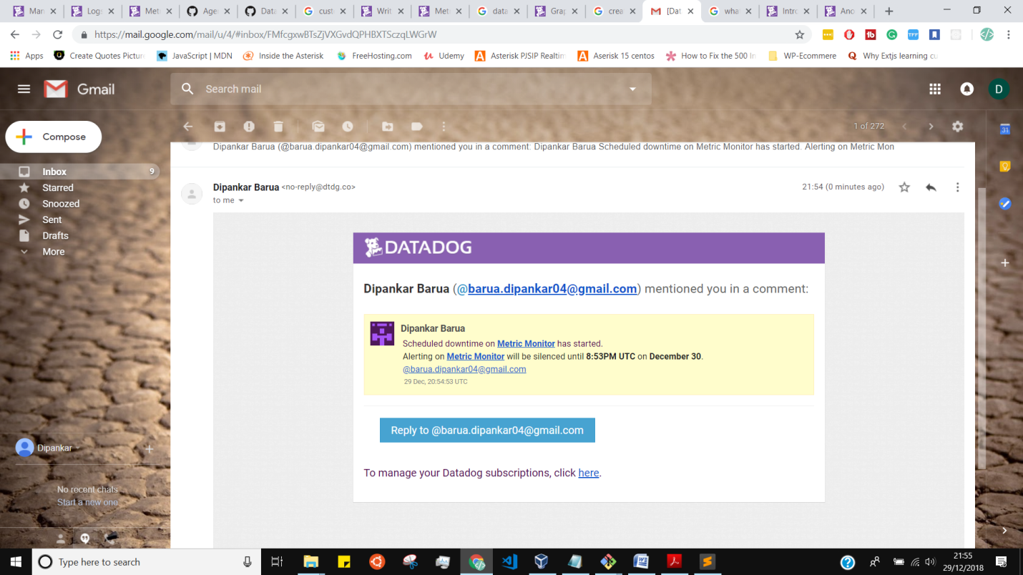

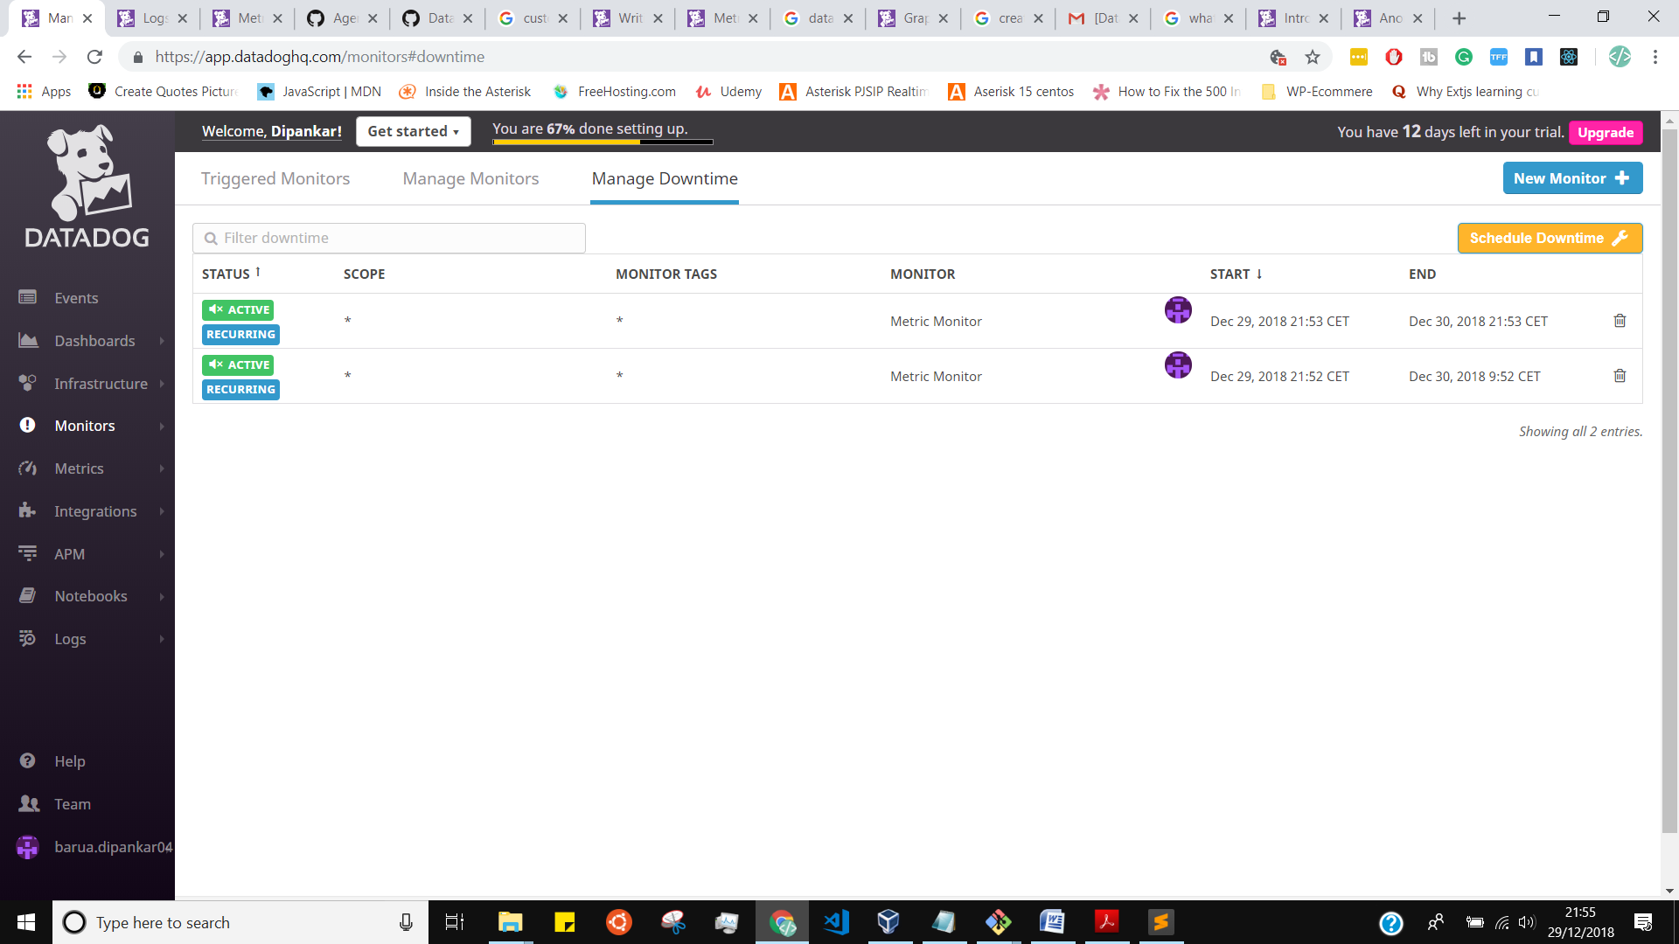

**Collecting APM Data:**

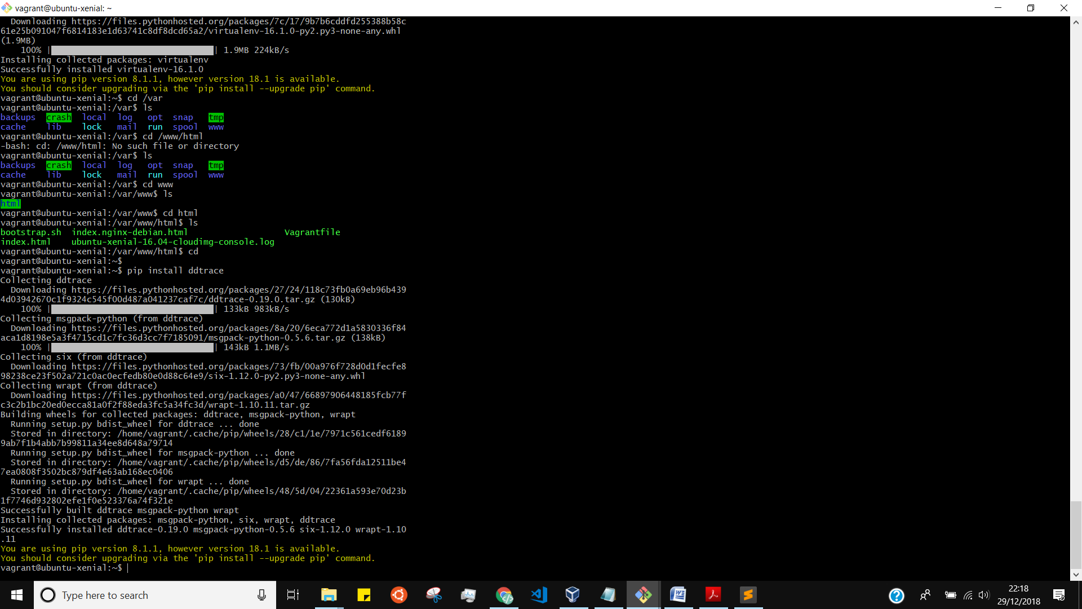

I installed all python flask related packages in to the server

Then later I created a file inside the agent checks.d foder

# vagrant@ubuntu-xenial:/etc/datadog-agent/checks.d$ ls

dashboard-via-script.py flask-app.py my_metric.py my_metric.pyc

flask-app.py

vagrant@ubuntu-xenial:/etc$ pip install datadog

Collecting datadog

Downloading https://files.pythonhosted.org/packages/17/dd/a7bbb33427f853f82b36356286fb922ef976bf18e78dbb76ac43b8c50e26/datadog-0.26.0.tar.gz (154kB)

100% |████████████████████████████████| 163kB 1.2MB/s

Collecting decorator>=3.3.2 (from datadog)

Downloading https://files.pythonhosted.org/packages/bc/bb/a24838832ba35baf52f32ab1a49b906b5f82fb7c76b2f6a7e35e140bac30/decorator-4.3.0-py2.py3-none-any.whl

Collecting requests>=2.6.0 (from datadog)

Downloading https://files.pythonhosted.org/packages/7d/e3/20f3d364d6c8e5d2353c72a67778eb189176f08e873c9900e10c0287b84b/requests-2.21.0-py2.py3-none-any.whl (57kB)

100% |████████████████████████████████| 61kB 2.1MB/s

Collecting certifi>=2017.4.17 (from requests>=2.6.0->datadog)

Downloading https://files.pythonhosted.org/packages/9f/e0/accfc1b56b57e9750eba272e24c4dddeac86852c2bebd1236674d7887e8a/certifi-2018.11.29-py2.py3-none-any.whl (154kB)

100% |████████████████████████████████| 163kB 1.4MB/s

Collecting chardet<3.1.0,>=3.0.2 (from requests>=2.6.0->datadog)

Downloading https://files.pythonhosted.org/packages/bc/a9/01ffebfb562e4274b6487b4bb1ddec7ca55ec7510b22e4c51f14098443b8/chardet-3.0.4-py2.py3-none-any.whl (133kB)

100% |████████████████████████████████| 143kB 1.1MB/s

Collecting idna<2.9,>=2.5 (from requests>=2.6.0->datadog)

Downloading https://files.pythonhosted.org/packages/14/2c/cd551d81dbe15200be1cf41cd03869a46fe7226e7450af7a6545bfc474c9/idna-2.8-py2.py3-none-any.whl (58kB)

100% |████████████████████████████████| 61kB 1.1MB/s

Collecting urllib3<1.25,>=1.21.1 (from requests>=2.6.0->datadog)

Downloading https://files.pythonhosted.org/packages/62/00/ee1d7de624db8ba7090d1226aebefab96a2c71cd5cfa7629d6ad3f61b79e/urllib3-1.24.1-py2.py3-none-any.whl (118kB)

100% |████████████████████████████████| 122kB 1.4MB/s

Building wheels for collected packages: datadog

Running setup.py bdist_wheel for datadog ... done

Stored in directory: /home/vagrant/.cache/pip/wheels/83/ad/89/ffe24c194922e51d6ce237e44b469d30d80fbeaf30e327aa30

Successfully built datadog

Installing collected packages: decorator, certifi, chardet, idna, urllib3, requests, datadog

Successfully installed certifi chardet datadog decorator idna requests urllib3

You are using pip version 8.1.1, however version 18.1 is available.

You should consider upgrading via the 'pip install --upgrade pip' command

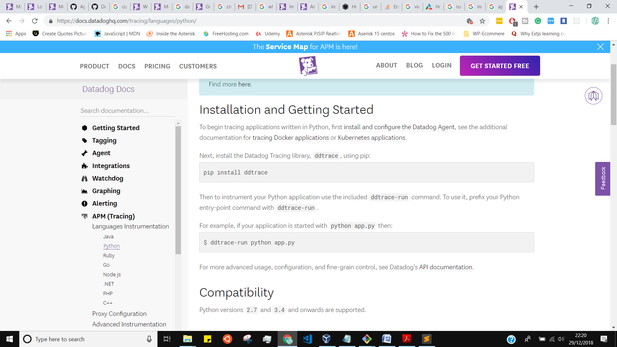

.

I run the flask app via ddtrace-run python flask-app.py

Then got the below logs:

INFO:werkzeug: * Running on http://0.0.0.0:5050/ (Press CTRL+C to quit)

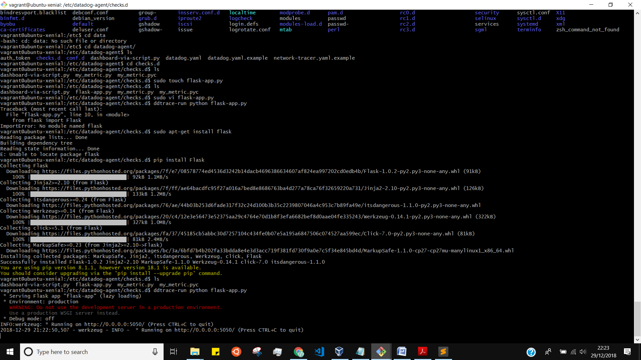

Apm is running dashboard

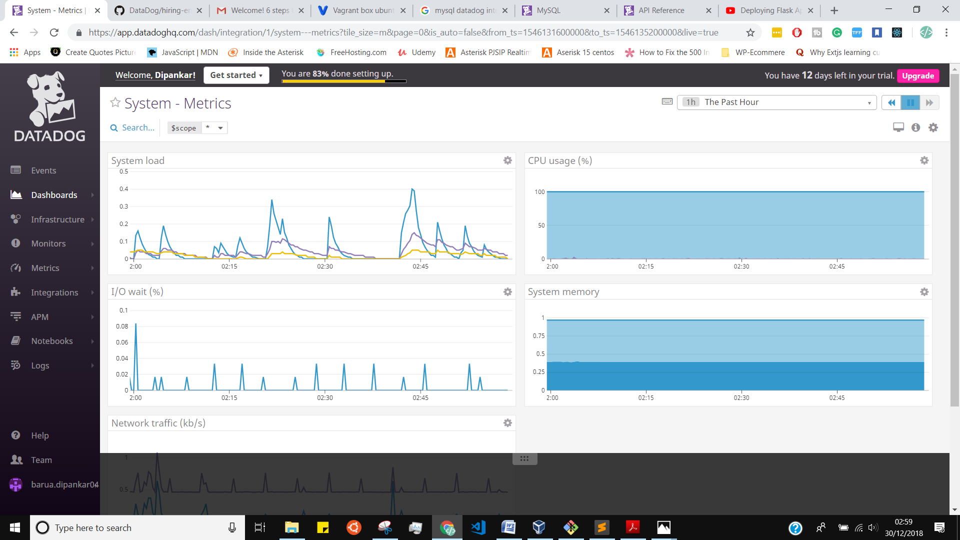

A**nother way I tried to run the flask app using virtutalenv and gurnicorn**

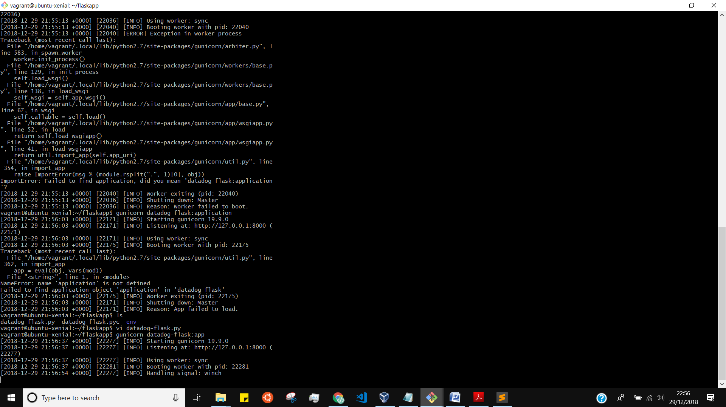

Anomaly detection is an algorithmic feature that allows you to identify when a metric is behaving differently than it has in the past, taking into account trends, seasonal day-of-week, and time-of-day patterns. It is well-suited for metrics with strong trends and recurring patterns that are hard or impossible to monitor with threshold-based alerting

**Bonus Question: What is the difference between a Service and a Resource?**

A "Service" is the name of a set of processes that work together to provide a feature set. For instance, a simple web application may consist of two services: a single webappservice and a single database service, while a more complex environment may break it out into 6 services: 3 separate webapp, admin, and query services, along with a master-db, a replica-db, and a yelp-api external service.

These services are defined by the user when instrumenting their application with Datadog. This field is helpful to quickly distinguish between your different processes.

In the Datadog UI, this is the "Name" field in the above image.  An example of setting a custom Service using Python:



**Resource**

A particular query to a service. For a web application, some examples might be a canonical URL like /user/home or a handler function like

web.user.home (often referred to as "routes" in MVC frameworks). For a SQL database, a resource would be the SQL of the query itself like select * from users where id = ?

The Tracing backend can track thousands (not millions or billions) of unique resources per service, so resources should be grouped together under a canonical name, like /user/home rather than have /user/home?id=100 and /user/home?id=200 as separate resources.

These resources can be found after clicking on a particular service.

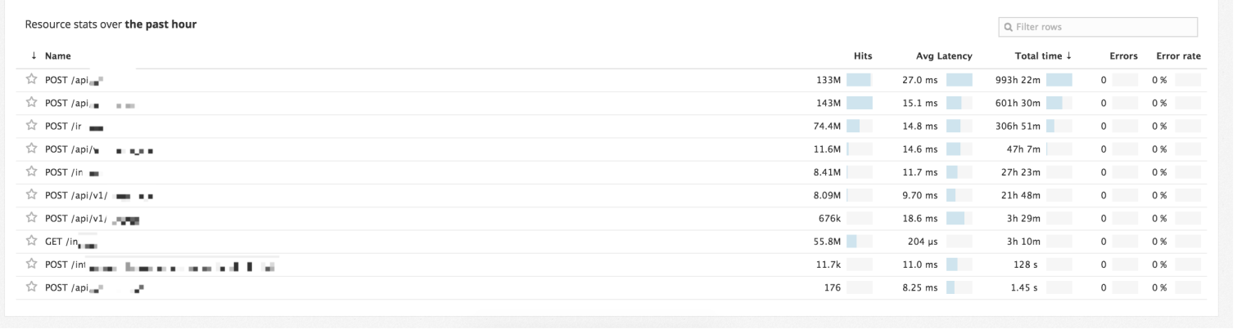

**Fianl Question**

**Datadog has been used in a lot of creative ways in the past. We’ve written some blog posts about using Datadog to monitor the NYC Subway System, Pokemon Go, and even office restroom availability!**

**Is there anything creative you would use Datadog for?**

I would like to integrate data dog with Health Industry. In the hospitals, there are a lot of patients with having different illnesses. we know that all the hospitals they have all the tools I mean the difference application to checkup the patient's conditions.in Realtime how patience health is improving we can know by using datadog and as well Hospitals authorisation can also confirm how can they improve patients health for future patients.

**Notes: sorry to say that I didn’t submit on deadline due to some personal reasons I needed some times to complete the task and Finally I would like to tell that I am really interested for this positions.**

**All events of data dogdog agents**

Now5 events1:004:007:0010:0013:0016:0019:0022:00

## 28 matching events from Dec 29, 12:00AM - Dec 30, 12:00AM Aggregate related events





Post



**Dipankar Barua started scheduled downtime on Metric Monitor**#audit #downtime #downtime_id:443823653 #monitor#monitor_id:7757433

Scheduled downtime on [**Metric Monitor**](https://app.datadoghq.com/monitors#7757433?) has started.   
Alerting on [**Metric Monitor**](https://app.datadoghq.com/monitors#7757433?) will be silenced until **8:53PM UTC** on **December 30**.

[**@barua.dipankar04@gmail.com**](https://app.datadoghq.com/account/profile/u-3FXgVxuEQi79)

[Sat Dec 29 2018 21:54:53 GMT+0100 (Central European Standard Time)](https://app.datadoghq.com/event/event?id=4728725943459752646) [· Add comment](https://app.datadoghq.com/event/stream?tags_execution=and&show_private=true&per_page=30&aggregate_up=true&use_date_happened=false&display_timeline=true&from_ts=1546038000000&priority=normal&live=true&is_zoomed=false&status=all&to_ts=1546124400000&is_auto=false&incident=true&only_discussed=false&no_user=false&page=0&bucket_size=1800000#comment) · [Lower priority](https://app.datadoghq.com/event/stream?tags_execution=and&show_private=true&per_page=30&aggregate_up=true&use_date_happened=false&display_timeline=true&from_ts=1546038000000&priority=normal&live=true&is_zoomed=false&status=all&to_ts=1546124400000&is_auto=false&incident=true&only_discussed=false&no_user=false&page=0&bucket_size=1800000)



**Dipankar Barua started scheduled downtime on Metric Monitor**#audit #downtime #downtime_id:443823435 #monitor#monitor_id:7757433

Scheduled downtime on [**Metric Monitor**](https://app.datadoghq.com/monitors#7757433?) has started.   
Alerting on [**Metric Monitor**](https://app.datadoghq.com/monitors#7757433?) will be silenced until **8:52AM UTC** on **December 30**.

[**@barua.dipankar04@gmail.com**](https://app.datadoghq.com/account/profile/u-3FXgVxuEQi79)

[Sat Dec 29 2018 21:53:15 GMT+0100 (Central European Standard Time)](https://app.datadoghq.com/event/event?id=4728724283154013628) [· Add comment](https://app.datadoghq.com/event/stream?tags_execution=and&show_private=true&per_page=30&aggregate_up=true&use_date_happened=false&display_timeline=true&from_ts=1546038000000&priority=normal&live=true&is_zoomed=false&status=all&to_ts=1546124400000&is_auto=false&incident=true&only_discussed=false&no_user=false&page=0&bucket_size=1800000#comment) · [Lower priority](https://app.datadoghq.com/event/stream?tags_execution=and&show_private=true&per_page=30&aggregate_up=true&use_date_happened=false&display_timeline=true&from_ts=1546038000000&priority=normal&live=true&is_zoomed=false&status=all&to_ts=1546124400000&is_auto=false&incident=true&only_discussed=false&no_user=false&page=0&bucket_size=1800000)



**[Monitor Created] Metric Monitor**#audit #monitor #monitor_id:7757433

**Dipankar Barua** created [**Metric Monitor**](https://app.datadoghq.com/monitors#7757433/edit).

The monitor:

* is named: Metric Monitor.
* has the query avg(last_5m):avg:my_metric{*} > 800.
* notifies if the metric has been missing data for the last **10m**.
* does not automatically resolve.
* includes the message: "[**@barua.dipankar04@gmail.com**](https://app.datadoghq.com/account/profile/u-3FXgVxuEQi79)"
* does not renotify.
* notifies recipients when the definition is modified.
* requires a full window of data - includes triggering tags in notification title.
* does not evaluate with a delay.

[Sat Dec 29 2018 21:39:35 GMT+0100 (Central European Standard Time)](https://app.datadoghq.com/event/event?id=4728710522445492368) [· Add comment](https://app.datadoghq.com/event/stream?tags_execution=and&show_private=true&per_page=30&aggregate_up=true&use_date_happened=false&display_timeline=true&from_ts=1546038000000&priority=normal&live=true&is_zoomed=false&status=all&to_ts=1546124400000&is_auto=false&incident=true&only_discussed=false&no_user=false&page=0&bucket_size=1800000#comment) · [Lower priority](https://app.datadoghq.com/event/stream?tags_execution=and&show_private=true&per_page=30&aggregate_up=true&use_date_happened=false&display_timeline=true&from_ts=1546038000000&priority=normal&live=true&is_zoomed=false&status=all&to_ts=1546124400000&is_auto=false&incident=true&only_discussed=false&no_user=false&page=0&bucket_size=1800000)



**Average Memory Free**

###### [Average Memory Free](https://app.datadoghq.com/dash/1032392/dipankar-barua-time-board?tile_size=m&page=0&is_auto=false&from_ts=1546114735371&to_ts=1546115035371&live=false&tags_execution=and&tile_focus=7501345245309846)

[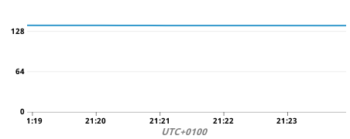](https://app.datadoghq.com/dash/1032392/dipankar-barua-time-board?tile_size=m&page=0&is_auto=false&from_ts=1546114735371&to_ts=1546115035371&live=false&tags_execution=and&tile_focus=7501345245309846)

[**@barua.dipankar04@gmail.com**](https://app.datadoghq.com/account/profile/u-3FXgVxuEQi79)

[Sat Dec 29 2018 21:25:42 GMT+0100 (Central European Standard Time)](https://app.datadoghq.com/event/event?id=4728696518218842116) · [View](https://app.datadoghq.com/dash/1032392/dipankar-barua-time-board?tile_size=m&page=0&is_auto=false&from_ts=1546114735371&to_ts=1546115035371&live=false&tags_execution=and&tile_focus=7501345245309846) [· Add comment](https://app.datadoghq.com/event/stream?tags_execution=and&show_private=true&per_page=30&aggregate_up=true&use_date_happened=false&display_timeline=true&from_ts=1546038000000&priority=normal&live=true&is_zoomed=false&status=all&to_ts=1546124400000&is_auto=false&incident=true&only_discussed=false&no_user=false&page=0&bucket_size=1800000#comment) · [Lower priority](https://app.datadoghq.com/event/stream?tags_execution=and&show_private=true&per_page=30&aggregate_up=true&use_date_happened=false&display_timeline=true&from_ts=1546038000000&priority=normal&live=true&is_zoomed=false&status=all&to_ts=1546124400000&is_auto=false&incident=true&only_discussed=false&no_user=false&page=0&bucket_size=1800000) · [Edit](https://app.datadoghq.com/event/stream?tags_execution=and&show_private=true&per_page=30&aggregate_up=true&use_date_happened=false&display_timeline=true&from_ts=1546038000000&priority=normal&live=true&is_zoomed=false&status=all&to_ts=1546124400000&is_auto=false&incident=true&only_discussed=false&no_user=false&page=0&bucket_size=1800000)



**A new application key has been created.**#account #audit

Application key mrbarua created by barua.dipankar04@gmail.com in org Datadog Recruiting Candidate

[Sat Dec 29 2018 19:30:55 GMT+0100 (Central European Standard Time)](https://app.datadoghq.com/event/event?id=4728580972494733313) [· Add comment](https://app.datadoghq.com/event/stream?tags_execution=and&show_private=true&per_page=30&aggregate_up=true&use_date_happened=false&display_timeline=true&from_ts=1546038000000&priority=normal&live=true&is_zoomed=false&status=all&to_ts=1546124400000&is_auto=false&incident=true&only_discussed=false&no_user=false&page=0&bucket_size=1800000#comment) · [Lower priority](https://app.datadoghq.com/event/stream?tags_execution=and&show_private=true&per_page=30&aggregate_up=true&use_date_happened=false&display_timeline=true&from_ts=1546038000000&priority=normal&live=true&is_zoomed=false&status=all&to_ts=1546124400000&is_auto=false&incident=true&only_discussed=false&no_user=false&page=0&bucket_size=1800000)



**ubuntu-xenial's Datadog Agent has started**#host:ubuntu-xenial

See ubuntu-xenial's [dashboard](https://app.datadoghq.com/dash/host_name/ubuntu-xenial)

Updated Sat Dec 29 2018 19:02:36 GMT+0100 (Central European Standard Time) · Created [Sat Dec 29 2018 18:14:55 GMT+0100 (Central European Standard Time)](https://app.datadoghq.com/event/event?id=4728504916322875804) [· Add comment](https://app.datadoghq.com/event/stream?tags_execution=and&show_private=true&per_page=30&aggregate_up=true&use_date_happened=false&display_timeline=true&from_ts=1546038000000&priority=normal&live=true&is_zoomed=false&status=all&to_ts=1546124400000&is_auto=false&incident=true&only_discussed=false&no_user=false&page=0&bucket_size=1800000#comment) · [Lower priority](https://app.datadoghq.com/event/stream?tags_execution=and&show_private=true&per_page=30&aggregate_up=true&use_date_happened=false&display_timeline=true&from_ts=1546038000000&priority=normal&live=true&is_zoomed=false&status=all&to_ts=1546124400000&is_auto=false&incident=true&only_discussed=false&no_user=false&page=0&bucket_size=1800000)

[**2** events](https://app.datadoghq.com/event/stream?tags_execution=and&show_private=true&per_page=30&aggregate_up=true&use_date_happened=false&display_timeline=true&from_ts=1546038000000&priority=normal&live=true&is_zoomed=false&status=all&to_ts=1546124400000&is_auto=false&incident=true&only_discussed=false&no_user=false&page=0&bucket_size=1800000)



**ubuntu-xenial's Datadog Agent has started**#host:ubuntu-xenial

See ubuntu-xenial's [dashboard](https://app.datadoghq.com/dash/host_name/ubuntu-xenial)

[Sat Dec 29 2018 18:40:23 GMT+0100 (Central European Standard Time)](https://app.datadoghq.com/event/event?id=4728530448459107265) [· Add comment](https://app.datadoghq.com/event/stream?tags_execution=and&show_private=true&per_page=30&aggregate_up=true&use_date_happened=false&display_timeline=true&from_ts=1546038000000&priority=normal&live=true&is_zoomed=false&status=all&to_ts=1546124400000&is_auto=false&incident=true&only_discussed=false&no_user=false&page=0&bucket_size=1800000#comment) · [Lower priority](https://app.datadoghq.com/event/stream?tags_execution=and&show_private=true&per_page=30&aggregate_up=true&use_date_happened=false&display_timeline=true&from_ts=1546038000000&priority=normal&live=true&is_zoomed=false&status=all&to_ts=1546124400000&is_auto=false&incident=true&only_discussed=false&no_user=false&page=0&bucket_size=1800000)



**[Auto] Clock in sync with NTP is ok on 1 over 1 host**#host:ubuntu-xenial #monitor

ntp.in_sync recovered on host:ubuntu-xenial

Triggers if any host's clock goes out of sync with the time given by NTP. The offset threshold is configured in the Agent's ntp.yaml file.

Please read the [KB article](https://docs.datadoghq.com/agent/faq/network-time-protocol-ntp-offset-issues) on NTP Offset issues for more details on cause and resolution.

[[Monitor Status](https://app.datadoghq.com/monitors#7707792?)] · [[Edit Monitor](https://app.datadoghq.com/monitors#7707792/edit)]

Updated Sat Dec 29 2018 18:16:11 GMT+0100 (Central European Standard Time) · Created [Sat Dec 29 2018 16:39:10 GMT+0100 (Central European Standard Time)](https://app.datadoghq.com/event/event?id=4728408088464900920) [· Add comment](https://app.datadoghq.com/event/stream?tags_execution=and&show_private=true&per_page=30&aggregate_up=true&use_date_happened=false&display_timeline=true&from_ts=1546038000000&priority=normal&live=true&is_zoomed=false&status=all&to_ts=1546124400000&is_auto=false&incident=true&only_discussed=false&no_user=false&page=0&bucket_size=1800000#comment) · [Lower priority](https://app.datadoghq.com/event/stream?tags_execution=and&show_private=true&per_page=30&aggregate_up=true&use_date_happened=false&display_timeline=true&from_ts=1546038000000&priority=normal&live=true&is_zoomed=false&status=all&to_ts=1546124400000&is_auto=false&incident=true&only_discussed=false&no_user=false&page=0&bucket_size=1800000)

[**2** events](https://app.datadoghq.com/event/stream?tags_execution=and&show_private=true&per_page=30&aggregate_up=true&use_date_happened=false&display_timeline=true&from_ts=1546038000000&priority=normal&live=true&is_zoomed=false&status=all&to_ts=1546124400000&is_auto=false&incident=true&only_discussed=false&no_user=false&page=0&bucket_size=1800000)



**ubuntu-xenial's Datadog Agent has started**#host:ubuntu-xenial

See ubuntu-xenial's [dashboard](https://app.datadoghq.com/dash/host_name/ubuntu-xenial)

Updated Sat Dec 29 2018 15:32:14 GMT+0100 (Central European Standard Time) · Created [Sat Dec 29 2018 14:54:20 GMT+0100 (Central European Standard Time)](https://app.datadoghq.com/event/event?id=4728302965938889988) [· Add comment](https://app.datadoghq.com/event/stream?tags_execution=and&show_private=true&per_page=30&aggregate_up=true&use_date_happened=false&display_timeline=true&from_ts=1546038000000&priority=normal&live=true&is_zoomed=false&status=all&to_ts=1546124400000&is_auto=false&incident=true&only_discussed=false&no_user=false&page=0&bucket_size=1800000#comment) · [Lower priority](https://app.datadoghq.com/event/stream?tags_execution=and&show_private=true&per_page=30&aggregate_up=true&use_date_happened=false&display_timeline=true&from_ts=1546038000000&priority=normal&live=true&is_zoomed=false&status=all&to_ts=1546124400000&is_auto=false&incident=true&only_discussed=false&no_user=false&page=0&bucket_size=1800000)

[**5** events](https://app.datadoghq.com/event/stream?tags_execution=and&show_private=true&per_page=30&aggregate_up=true&use_date_happened=false&display_timeline=true&from_ts=1546038000000&priority=normal&live=true&is_zoomed=false&status=all&to_ts=1546124400000&is_auto=false&incident=true&only_discussed=false&no_user=false&page=0&bucket_size=1800000)



**ubuntu-xenial's Datadog Agent has started**#host:ubuntu-xenial

See ubuntu-xenial's [dashboard](https://app.datadoghq.com/dash/host_name/ubuntu-xenial)

[Sat Dec 29 2018 15:12:59 GMT+0100 (Central European Standard Time)](https://app.datadoghq.com/event/event?id=4728321736133834371) [· Add comment](https://app.datadoghq.com/event/stream?tags_execution=and&show_private=true&per_page=30&aggregate_up=true&use_date_happened=false&display_timeline=true&from_ts=1546038000000&priority=normal&live=true&is_zoomed=false&status=all&to_ts=1546124400000&is_auto=false&incident=true&only_discussed=false&no_user=false&page=0&bucket_size=1800000#comment) · [Lower priority](https://app.datadoghq.com/event/stream?tags_execution=and&show_private=true&per_page=30&aggregate_up=true&use_date_happened=false&display_timeline=true&from_ts=1546038000000&priority=normal&live=true&is_zoomed=false&status=all&to_ts=1546124400000&is_auto=false&incident=true&only_discussed=false&no_user=false&page=0&bucket_size=1800000)



**ubuntu-xenial's Datadog Agent has started**#host:ubuntu-xenial

See ubuntu-xenial's [dashboard](https://app.datadoghq.com/dash/host_name/ubuntu-xenial)

[Sat Dec 29 2018 14:44:46 GMT+0100 (Central European Standard Time)](https://app.datadoghq.com/event/event?id=4728293276707374116) [· Add comment](https://app.datadoghq.com/event/stream?tags_execution=and&show_private=true&per_page=30&aggregate_up=true&use_date_happened=false&display_timeline=true&from_ts=1546038000000&priority=normal&live=true&is_zoomed=false&status=all&to_ts=1546124400000&is_auto=false&incident=true&only_discussed=false&no_user=false&page=0&bucket_size=1800000#comment) · [Lower priority](https://app.datadoghq.com/event/stream?tags_execution=and&show_private=true&per_page=30&aggregate_up=true&use_date_happened=false&display_timeline=true&from_ts=1546038000000&priority=normal&live=true&is_zoomed=false&status=all&to_ts=1546124400000&is_auto=false&incident=true&only_discussed=false&no_user=false&page=0&bucket_size=1800000)



**MySQL has been manually created.**

Integration configuration created by [Dipankar Barua](https://app.datadoghq.com/account/member/u-3FXgVxuEQi79).

[Sat Dec 29 2018 14:28:54 GMT+0100 (Central European Standard Time)](https://app.datadoghq.com/event/event?id=4728276984624712228) [· Add comment](https://app.datadoghq.com/event/stream?tags_execution=and&show_private=true&per_page=30&aggregate_up=true&use_date_happened=false&display_timeline=true&from_ts=1546038000000&priority=normal&live=true&is_zoomed=false&status=all&to_ts=1546124400000&is_auto=false&incident=true&only_discussed=false&no_user=false&page=0&bucket_size=1800000#comment) · [Lower priority](https://app.datadoghq.com/event/stream?tags_execution=and&show_private=true&per_page=30&aggregate_up=true&use_date_happened=false&display_timeline=true&from_ts=1546038000000&priority=normal&live=true&is_zoomed=false&status=all&to_ts=1546124400000&is_auto=false&incident=true&only_discussed=false&no_user=false&page=0&bucket_size=1800000)



**MySQL has been manually deleted.**

Integration configuration deleted by [Dipankar Barua](https://app.datadoghq.com/account/member/u-3FXgVxuEQi79).

The integration dashboards have been removed, but you also need to manually change the agent configuration to stop metric collection.

[Sat Dec 29 2018 14:25:54 GMT+0100 (Central European Standard Time)](https://app.datadoghq.com/event/event?id=4728273935548681298) [· Add comment](https://app.datadoghq.com/event/stream?tags_execution=and&show_private=true&per_page=30&aggregate_up=true&use_date_happened=false&display_timeline=true&from_ts=1546038000000&priority=normal&live=true&is_zoomed=false&status=all&to_ts=1546124400000&is_auto=false&incident=true&only_discussed=false&no_user=false&page=0&bucket_size=1800000#comment) · [Lower priority](https://app.datadoghq.com/event/stream?tags_execution=and&show_private=true&per_page=30&aggregate_up=true&use_date_happened=false&display_timeline=true&from_ts=1546038000000&priority=normal&live=true&is_zoomed=false&status=all&to_ts=1546124400000&is_auto=false&incident=true&only_discussed=false&no_user=false&page=0&bucket_size=1800000)



**ubuntu-xenial's Datadog Agent has started**#host:ubuntu-xenial

See ubuntu-xenial's [dashboard](https://app.datadoghq.com/dash/host_name/ubuntu-xenial)

[Sat Dec 29 2018 13:31:27 GMT+0100 (Central European Standard Time)](https://app.datadoghq.com/event/event?id=4728219701354040316) [· Add comment](https://app.datadoghq.com/event/stream?tags_execution=and&show_private=true&per_page=30&aggregate_up=true&use_date_happened=false&display_timeline=true&from_ts=1546038000000&priority=normal&live=true&is_zoomed=false&status=all&to_ts=1546124400000&is_auto=false&incident=true&only_discussed=false&no_user=false&page=0&bucket_size=1800000#comment) · [Lower priority](https://app.datadoghq.com/event/stream?tags_execution=and&show_private=true&per_page=30&aggregate_up=true&use_date_happened=false&display_timeline=true&from_ts=1546038000000&priority=normal&live=true&is_zoomed=false&status=all&to_ts=1546124400000&is_auto=false&incident=true&only_discussed=false&no_user=false&page=0&bucket_size=1800000)



**ubuntu-xenial's Datadog Agent has started**#host:ubuntu-xenial

See ubuntu-xenial's [dashboard](https://app.datadoghq.com/dash/host_name/ubuntu-xenial)

[Sat Dec 29 2018 03:47:09 GMT+0100 (Central European Standard Time)](https://app.datadoghq.com/event/event?id=4727631400185023576) [· Add comment](https://app.datadoghq.com/event/stream?tags_execution=and&show_private=true&per_page=30&aggregate_up=true&use_date_happened=false&display_timeline=true&from_ts=1546038000000&priority=normal&live=true&is_zoomed=false&status=all&to_ts=1546124400000&is_auto=false&incident=true&only_discussed=false&no_user=false&page=0&bucket_size=1800000#comment) · [Lower priority](https://app.datadoghq.com/event/stream?tags_execution=and&show_private=true&per_page=30&aggregate_up=true&use_date_happened=false&display_timeline=true&from_ts=1546038000000&priority=normal&live=true&is_zoomed=false&status=all&to_ts=1546124400000&is_auto=false&incident=true&only_discussed=false&no_user=false&page=0&bucket_size=1800000)



**MySQL has been manually created.**

Integration configuration created by [Dipankar Barua](https://app.datadoghq.com/account/member/u-3FXgVxuEQi79).

[Sat Dec 29 2018 03:44:21 GMT+0100 (Central European Standard Time)](https://app.datadoghq.com/event/event?id=4727628141749567469) [· Add comment](https://app.datadoghq.com/event/stream?tags_execution=and&show_private=true&per_page=30&aggregate_up=true&use_date_happened=false&display_timeline=true&from_ts=1546038000000&priority=normal&live=true&is_zoomed=false&status=all&to_ts=1546124400000&is_auto=false&incident=true&only_discussed=false&no_user=false&page=0&bucket_size=1800000#comment) · [Lower priority](https://app.datadoghq.com/event/stream?tags_execution=and&show_private=true&per_page=30&aggregate_up=true&use_date_happened=false&display_timeline=true&from_ts=1546038000000&priority=normal&live=true&is_zoomed=false&status=all&to_ts=1546124400000&is_auto=false&incident=true&only_discussed=false&no_user=false&page=0&bucket_size=1800000)



**ubuntu-xenial's Datadog Agent has started**#host:ubuntu-xenial

See ubuntu-xenial's [dashboard](https://app.datadoghq.com/dash/host_name/ubuntu-xenial)

[Sat Dec 29 2018 02:38:45 GMT+0100 (Central European Standard Time)](https://app.datadoghq.com/event/event?id=4727562500809588174) [· Add comment](https://app.datadoghq.com/event/stream?tags_execution=and&show_private=true&per_page=30&aggregate_up=true&use_date_happened=false&display_timeline=true&from_ts=1546038000000&priority=normal&live=true&is_zoomed=false&status=all&to_ts=1546124400000&is_auto=false&incident=true&only_discussed=false&no_user=false&page=0&bucket_size=1800000#comment) · [Lower priority](https://app.datadoghq.com/event/stream?tags_execution=and&show_private=true&per_page=30&aggregate_up=true&use_date_happened=false&display_timeline=true&from_ts=1546038000000&priority=normal&live=true&is_zoomed=false&status=all&to_ts=1546124400000&is_auto=false&incident=true&only_discussed=false&no_user=false&page=0&bucket_size=1800000)



**ubuntu-xenial's Datadog Agent has started**#host:ubuntu-xenial

See ubuntu-xenial's [dashboard](https://app.datadoghq.com/dash/host_name/ubuntu-xenial)

[Sat Dec 29 2018 02:31:45 GMT+0100 (Central European Standard Time)](https://app.datadoghq.com/event/event?id=4727555482579861169) [· Add comment](https://app.datadoghq.com/event/stream?tags_execution=and&show_private=true&per_page=30&aggregate_up=true&use_date_happened=false&display_timeline=true&from_ts=1546038000000&priority=normal&live=true&is_zoomed=false&status=all&to_ts=1546124400000&is_auto=false&incident=true&only_discussed=false&no_user=false&page=0&bucket_size=1800000#comment) · [Lower priority](https://app.datadoghq.com/event/stream?tags_execution=and&show_private=true&per_page=30&aggregate_up=true&use_date_happened=false&display_timeline=true&from_ts=1546038000000&priority=normal&live=true&is_zoomed=false&status=all&to_ts=1546124400000&is_auto=false&incident=true&only_discussed=false&no_user=false&page=0&bucket_size=1800000)